**How to play Trickster** - complete guide for newbies (both new to the game and returning players!) for epTO.

The server-specific features gloss over things that are central key points to this server, as well as specific changes. The [general Trickster knowledge](https://docs.google.com/document/d/1JvamUWh1hnFgDZEXQw1U6ELqJqZfyFi4EfCEVyADIXQ/edit#heading=h.s5znqiam3upb) is for people who have never experienced Trickster before and need somewhere to start, or for people who need a refresher on the systems involved.

Feel free to scroll down to the Index, or to click it on the left, to get started! There’s plenty of information here at your disposal.

I also include my own personal leveling system (FastLane) and guide-markers for how I grind up until 3rd job, your first checkpoint on the server, which is obtainable in a day or two with ease thanks to many changes on the server!

**Also: This guide is intended for desktop/laptops and may not look good on mobile with the images and formatting.**

**Last updated: 4/17/24**

# 

# Index:

**Index: 2**

**FAQ for the Lazy: 7**

Setup & Server Info 7

Gameplay 8

PvE/PvP Tier lists (courtesy of @d7jon/D7/Enel in the Discord): 9

Harkon Defense Tier List (courtesy of @yuragi in the Discord) 10

Guide 11

Misc 11

**Vocabulary: 12**

**QuickList of Wiki Links & References 15**

**Server-specific Features 16**

**Quick and Dirty Tips for All New Players 17**

Paula 18

General Info 18

How to Build Her (thanks to @hisyaryu_ on the Discord) 18

Early Game (thanks to @hisyaryu_ on the Discord) 18

Gearing (Early Game; thanks to @hisyaryu_ on the Discord) 19

Mid to Late Game (3rd job to 400; thanks to @hisyaryu_ on the Discord): 19

Gear (lv 200+; thanks to @hisyaryu_ on the Discord) 19

Late Game Gear (thanks to @hisyaryu_ on the Discord) 19

Other Information 19

Major Vanilla Quirks 20

Mail System 20

Custom System Mail Rewards 20

Cooldown Bug & Buffing 20

Pet Quirks (Rclick Disconnects & No Autoloot/Voice Pets) 21

Resolution change issues 21

Tradable Timed Items + Trading Expiry 21

Right-Clicking Guard Break 21

Fortune Logout Countdown 21

Character Slot Expansion 21

Graph Reset Level Transposition 22

Guardian Skill Saving 22

QoL/Skill/Other Changes 23

QOL 23

Drop Rate Chance Increases 24

Skill Changes 24

Ari’s Exchange/Ari’s Scavenger Hunt 26

Important item: Daily Coupons! 26

The Exchanges: 26

Eternal Tickets & Eternal Exchanges 35

General Info 35

How to Obtain 35

Character Box Exchanges per Level 35

Eternal Boxes 35

Contents of each Eternal Box: 36

MyShop Boxes 36

Eternal Eggs 37

Eternal Penguins 38

Eternal Penguin Bag 2 contents (does not rotate) 38

Harkon Shard Compound Exchange 39

Basic Info 39

Exchanges: 40

Website Features 41

Account 41

Game 41

Market 41

How to pay with MS for an ingame item (MS trade): 41

QoL 42

Event 42

Faded Tower - WIP 43

Anticipated Path of Progression: 44

FastLaneTM Method of Leveling to 3rd: 45

How to Grind Galder 47

When you first start: 47

Buffed farming areas: 47

The following fields are affected: 47

Recommendation: 47

Ways to NOT grind galder: 48

How to Gear/Compare Gear per Patch 49

My Recc. for First Characters: 49

With each Patch: 49

For example (outdated–All Character boxes are 3s and are always available so this is not an efficient comparison; will change later): 49

Custom Fuses 51

Custom Fashion 59

**General Trickster Knowledge 63**

Controls and Secret Controls 64

Other Controls: 64

Some Commands (case-sensitive): 64

Drilling 66

Basic Info 66

How to Drill 66

Crazy Drilling 67

Tips 67

Important NPCs and Their Functions 68

Chaos Tower (CT) 72

How to start: 72

What to do when you’re there: 72

How to do Dailies: 73

Easy (and easier) method to going the whole tower for Dailies: 73

Titles 73

All the Mats & # of Titles Required: 74

How to apply a Mat to your Shop: 74

Refining 76

Basic Info 76

Refine Stone Basic Bracket Types 76

Mine Locations & Depth 76

Stones in Each Mine & Levels for Refine 76

- Desert Crystal Copper: 76

- Caballa Jade Steel: 77

- Swamp Silver Jewel: 77

- Snow Precious Jewel: 77

- Techichi Golden Ash: 77

- Tapasco Silent Lava: 78

Refine Charts For How Much You’ll Need: 78

Physical Weapons 79

Physical Hats and Shields 80

Magical Weapons 81

Magical Hats and Shields 82

Tempering - WIP 83

Basic info: 83

MyShop 85

Basic Info 85

Types of Items You Can Buy: 85

Gift/Gifting: 86

MyCamp 87

General Info 87

How to Set Up Your MyCamp 87

Decorating Your MyCamp 87

Types of Items Available in the Store & Descriptions 88

Fiesta 89

Basic Info 89

Level Brackets and Associated Zone Names 89

Pets 90

To compound (“equip hardant”) a pet: 90

To Fuse & Unfuse a pet: 90

To Temper (“Train”) a pet: 90

Pet Breeding/Evolving: 91

Synergizing Pets: 91

Driller Pets/AFK Pets 92

Recycling - WIP 93

Basic Info 93

Treasure Maps & Black Market - WIP 94

1:1 Trading System 95

Parties & XP Share - WIP 98

Guilds 99

General Info 99

How to join a guild 99

Marriage - WIP 100

Quests + Questlog 101

Basic info 101

Quest Log 101

Fortune - WIP 103

Compounding - WIP 104

Mature Compounding - WIP 105

Exchange - WIP 106

Guardian TLDR 107

General Info 107

TLDR of How to Obtain One 107

How CID works 107

I Finished My Guardian, What Should I Do Now? 108

Harkon Defense TLDR - WIP 109

General Info 109

Bossing TLDR - WIP 110

**Post-end Game PvE Tips to Keep Playing! 111**

About This Section 111

Have you….. 111

Uphill Grinds Of Godly Flexhood 112

When All Else Fails… 112

# 

# FAQ for the Lazy:

### Setup & Server Info

**Q: My game won’t load/I have an error!**

A: [Setup Instructions for Eternal Paula](https://docs.google.com/document/d/1HQALbmvLqGPk5vrlz5R6VYvJlkDx2sug4MEl47nRAFI/edit#heading=h.j4egz71q7tls) < Follow this document. If it doesn’t work, submit a support ticket in **#support-ticket** on the Discord server.

**Q: How do I adjust my resolution?**

A: Go to your Eternal Paula main folder > Trickster folder > and click on setup.exe

**Q: Server Rates?**

A: XP is x6 for quests and x12 for regular grinding, but drop rate is 1x

**Q: Server location?**

A: Quebec, Canada. Time is in PST.

**Q: I am from a country other than Canada/my internet is slow–how can I fix my lag?**

A: Try either a VPN, PingZapper, or ExitLag.

**Q: What server-specific features are there?**

A: Read the server-specific feature headlines, and if you don’t understand what they are, read the contents.

**Q: What events are going on/boxes in rotation?**

A: Check patchnotes on the website.

**Q: I want to report a player/get technical support/report a game-breaking/exploitable bug!**

A: Submit a **#support-ticket** on the main Discord and a member of staff will get back to you.

**Q: Can I multiclient/have alternate accounts?**

A: Yes, and I encourage it for later game gameplay. However, the server has discouraged the use of multiple accounts/usage of farming multiple accounts by increasing things such as ticket prices for Eternal Ticket Exchanges and decreasing Eternal Ticket drop rates.

**Q: Where can I see the skill changes/other QoL improvements?**

A: Check out the QoL/skill changes section.

**Q: Can I use an autoclicker/macro?**

A: Botting is **not** allowed, however, autoclickers are a grey area that I believe are okay under certain circumstances, such as opening poppouri boxes for the poppouri event. I would not macro if you can help it, nor autoclicking. Ask staff before doing it, in my opinion.

**Q: Can I rebind my keys?**

A: No.

**Q: Not even with AutoHotKey?**

A: You mean the macro software? Why would you even try or suggest that on a server where botting is not allowed? This is not the first time it is brought up and it will not be the last. Do not suggest this.

### Gameplay

**Q: How do I obtain an autoloot pet?**

A: There is none.

**Q: How do I AFK grind galder?**

A: You can’t.

**Q: How to I actively grind galder?**

A: “Path to…” areas, CT, Tap 1. Also, check out the How to Grind Galder section.

**Q: How do I grind Eternal Tickets?**

A: High leveled areas, Harkon Defense.

**Q: What is in the Eternal [X] Box?**

A: Check out the list of contents here.

**Q: How do I join a guild? It won’t let me in-game.**

A: Log into the website and click “Guild”.

**Q: What is the path of progression I should be doing for my journey?**

A: Check Anticipated Path of Progression section.

**Q: I want to level up quick!**

A: Rates are buffed here to begin with, but I include my powerleveling service’s general outline in the FastLane section. I plan on releasing the full details if/when I quit.

**Q: Where can I find out about where to get Chaos Feathers other than with Party Quests?**

A: Hunter Yuri/Yuna in each town has her own. Check at the CF vocabulary section for a picture of which CFs you get where. (CF-dedicated section coming soon). Also, Eternal Penguins drop certain CFs in their boxes.

**Q: What gear should I get?**

A: Start with town sets, as they are buffed here, then progress to CT gear/190 gear from character boxes, and then specific MyShop/Eternal Exchange boxes for your class.

**Q: Do you recommend Paula?**

A: Not as a *first* character because she is tuned to be horrible early-game and powerful late, but she is the most powerful character right now, so you want her in your arsenal/zoo at some point.

**Q: How do I exchange Eternal Tickets?**

A: Compounder Nadia in Mega Shop.

**Q: Is there daily things to do?**

A: Yes, CT has bosses that you can do daily as well as quests around the server per town for most towns that grant Daily Coupons, which are used in Ari’s Exchange. You also can do Fiesta twice a day for optimal leveling.

**Q: What classes are best?**

A: The most popular classes are Scientist, Mercenary (Gladiators do well with bossing though), Thief Master (not as common), Witch (reliable for new players; Soulmaster is good if you know what you’re doing), Priest, and Paula (only one job; not great for new players’ first character). Other classes have one or two characters/people playing them, but they are not exactly the most optimal. Dark Lord is up-and-coming with his new buff, however.

#### **PvE/PvP Tier lists** (courtesy of @d7jon/D7/Enel in the Discord):

**PvE Meta**

| S | Paula, Gladiator |
| --- | --- |
| A | Witch, Champion, Mercenary, Duelist |
| B | Soulmaster, Scientist, Thief Master |
| C | Everyone else |

**DISCLAIMER**: This is an opinion of a high-ranking player whom other players may agree or disagree with. At the end of the day, it is still a subjective opinion.

**PvP Meta**

| S | Mercs (kings of pvp), Priest (best supports) and Gamblers (best cc and good and dmg) |
| --- | --- |
| A | Champ (hard to play unless you main), thief master (good mage killer) and dukes (amazing cc and tank) |
| B | SM (only good depending on the player) and Glad (good dmg dealers with aoes; watch out for the waterworks) and Paula (slow attacks, attacks easy to dodge but good debuffs and damage) |
| C | Scientists (could be higher depending on the player), Witches (good cc and dmg dealers if their person they're attacking doesn’t have res) Darklord (good damage dealers and debuffs) |
| D | Everything Else |

**cc** = crowd control

**DISCLAIMER**: This is a huge generalization. There are many factors that make the tier list relative/subject to change. i.e. 1v1, 4v4, equipment, war, individual players skill to play that character, etc.

#### Harkon Defense Tier List (courtesy of @yuragi in the Discord)

| S | Soulmaster (wind/earth) / (elec/fire), Scientist, Mercenary, Paula (with Spin bug) |
| --- | --- |
| A | Witch (elec/fire), Wizard (elec/fire), Cyberhunter, Hunter Lord |
| B(elow) | All other characters, Paula (if no spin bug) |

**IF THERE ARE MANY PEOPLE, PAULA IS BEST!**

**DISCLAIMER**: This is an opinion of one of the high ranking players and not all players may agree or disagree with this assessment. At the end of the day, it is still a subjective opinion.

**Q: How do I get f2p compound stones?**

A: Card ID, monsters. I have suggested a NPC that you exchange 500g coupons for the stones and the staff have mentioned that it’s in discussion, however, that does not mean it will be implemented. You can see where to get most stones by searching “[stat] compoundable Trickster” on Google. Also, [here is a list of stones for AP specifically](https://wikimirror.lifeto.co/wiki.ggftw.com/trickster/AP_Compound.html), but the compound stones themselves are the same for each type. The monster drops, however, are not. Later on, when you do Harkon Defense, you can get shards that you can exchange after completing episodes 5+6 for crests which grant high rolled compounds, as well as all Magic Stones available in MyShop

**Q: Is there a f2p driller boy?**

A: Yes, through Ari’s Exchange, but it is a massive grind, but she has lower recharge rates than the normal driller boy.

**Q: How do I get pets?**

A: MyShop boxes, events, player shops, primarily. There are some ways in game to get some, but they are generally a pain to obtain, such as the Coolem at Tapasco Spa (complete RNG, not guaranteed)

**Q: I need help with Guardian!**

A: Check out my guardian guide here: [Guide and stuff](https://docs.google.com/document/d/1aBNHRh0bInYsKX6B9D638mKOj80Wg3GiAmWLeu5m-50/edit)

**Q: Where do I grind cards for guardian?**

A: Cora Field 2 or Tap 1.

### Guide

**Q: Are you a mod/staff?**

A: No.

**Q: How long has it taken you to make this guide?**

A: Yes.

**Q: This guide seems very disjointed/out-of-proper-order.**

A: I am a disjointed/out-of-proper-order type of guy. Also, this is a WIP, please be nice :( I welcome constructive criticism and critique but not being a meanie bo beanie.

**Q: Is the rest of your guide this crass?**

A: No, I just appreciate people who read the whole thing more than people who just read the FAQ or one headline and click off. Since I can’t tell who will do either, I am just keeping this FAQ as short and concise as possible.

### Misc

**Q: Do you get kitty sprint from kitty character boxes?**

A: Yes.

**Q: How about other character accessories from character boxes?**

A: Yes.

# 

# Vocabulary:

* **MyShop**: In-game store that is powered by real currency. Yup, this is where they get you with transactions, and me, everytime. Includes boxes, fuses, timed accessories/capes, various quality of life items
* **MS**: MyShop or MyShop points themselves; items are either paid-exclusive or able to be obtained in other ways, but is readily available in MyShop (pressing Y); “points” are the currency used to purchase MyShop items in MyShop
* **ign/IGN**: In-game name; your character name (NOT your account name!!! Do not share that with anyone!!!)
* **eTO**: English Trickster Online, the original official English server
* **rTO**: PlayTrickster, another private server, formerly the biggest and one of the first to roll out, known for being “p2w”
* **p2w**: “Pay to win”, basically requiring real life currency/MyShop points for progression or to be able to adequately compete
* **f2p**: “Free to play”, progression able to be easily obtained by in-game methods rather than needing real life currency to obtain or complete
* **PvP**: “Player vs Player”, certain gameplay that revolves around slaying another player and competing with other players
* **PvE**: “Player vs Everything”, certain gameplay that revolves around slaying monsters
* **QoL**: “Quality of Life”, something that enhances the gameplay experience and makes it feel smoother or more enjoyable
* **log/relog**: entering or re-entering the game, after putting your account information in and selecting your character
* **RMT**: “real money trade”, selling in-game items for real life money directly instead of MyShop or Galder. **THIS IS A BANNABLE OFFENSE; DO NOT PARTICIPATE IN IT! REPORT ANYONE FOR THIS IMMEDIATELY**! It ruins the in-game economy by having it around!!! It also is an easy way that people scam players who don’t know any better!!
* **Mule/Alt**: An alternate character other than your main character; usually your second character and beyond
* **Whale**: Someone who spends a lot of money or has a lot of valuable items
* **Acc**: “account” or “accessory”--context is important for this abbreviation; it either is referring to your game account as a whole, or the accessory slot/a type of equipment
* **Roll**: “to chance in a gamble”, basically. A lot of Trickster requires “rolling” or chancing on gacha/gambling.
* **Town Sets**: the sets that require exchange items in each town, other than Paradise, such as the Caballa Slates for Neo Caballa Gear, usually with the NPC **Mint** in each town
* **Fuse/fusion**: the process by which the looks of an item is applied to another item’s stats, resulting in one piece of equipment. Uses Artisan Flames, also known as Fuse Flames.
* **Artisan Flames**: Also known as “Fuse Flames”. MS-exclusive item used for applying and removing fuses from each other for equipment as well as removal of skins for pets.
* **Mature Compound/Compound/Comping**: An ability to modify equipment with certain stats to boost their stats and make the equipment last longer/more powerful. This is a gamble, and can use items such as elixirs (Amethyst and Pink are best combination for highest range but White/Green and Pink is safer for most players) to modify the result. Done at **Alchemist Nate**.
* **Xs**: Indicates the number of slots per gear when used in the context of an equip. Usually seen as 1s, 2s, 3s, 4s, 5s. (e.g. *3s* Sheep Cape 210)
* **Compounding**: Done usually with Compounder Paul, not to be confused with Mature Compounding, but often used the same phrasing (*comping*) with expected context clues.
* **CT**: Chaos Tower, a place dedicated to grinding and leveling as well as daily boxes to roll for equipment
* **Eternal Eggs**: Galder-based gambling that changes based on the patch. Check patchnotes to see what’s in them. They’re found with the NPCs under the statue in Megalopolis at the 4 Item-based NPCs there. *THESE ARE NOT AVAILABLE WITH MYSHOP!!!!*
* **Eternal Tickets**: tickets that have a % chance of being dropped by all monsters and guaranteed by Episode Quest rewards; used for exchanging for MyShop boxes; exchange with Compounder Nadia in Mega Shop
* **Hardant**: Pet-specific “mature compound”. Only done at a specific NPC **Pet Trainer Shara** as “Equip Hardant” or “Remove Hardant”. Needs a Shara Bottle to remove, which is MS-exclusive.
* **OHKO**: One-hit-knock-out or One hit kill, very self-explanatory from then on.
* **Tempering**: Each equip has a specific range it can change its stats for. Specific boxes give equipment
* **Refining**: Leveling up a stat, based on a predetermined stat per equipment. You use specific gems found in each town for specific pieces of equipment. Right click a piece of equipment and look at the bottom right for what stat it Refines for, and Refine with Blacksmith Marx.
* **Skill Mastery**: The way to make your skills the most powerful they can be. Increases range for AoEs and power usually, but also the amount of MP needed to cast. Requires specific cards to do so.
* **BIS**: “Best in Slot”. Basically, the best stat you can get by opening the box in and of itself, or the best desired stat available for that specific equipment.
* **Mega**: Megalopolis, the major town for teleport, transport, and function.
* **CFs/Chaos Feathers**: Used for tempering. Found at the following places: (**Please note** that “Gate of Techichi” should be “Neil’s Camp”). Requires 3x per temper, and is random from those quests. You also can obtain these by Party Quests, but they aren’t as great, especially for XP, and require more than one character to do (best with a full party)

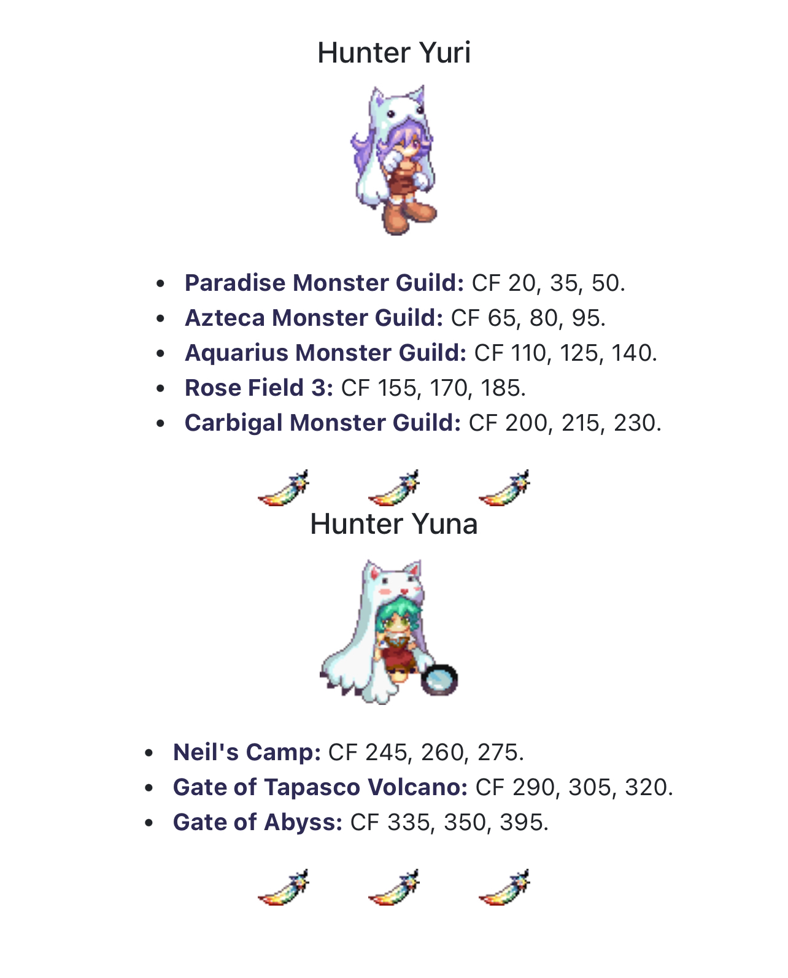

# QuickList of Wiki Links & References

Coming soon

**LIFETO ITEM KNOWLEDGEBASE (individual item lookup) -** [**https://knowledge.lifeto.co/**](https://knowledge.lifeto.co/)

**PAULA SKILLS -** [**https://oto.fandom.com/wiki/Bear_Skills**](https://oto.fandom.com/wiki/Bear_Skills)

Refining - <https://wikimirror.lifeto.co/wiki.ggftw.com/trickster/Refinement.html>

Mature Compounding - <https://wikimirror.lifeto.co/wiki.ggftw.com/trickster/Maturing_Compound.html>

Star Gazing/Fortune - <https://wikimirror.lifeto.co/wiki.ggftw.com/trickster/Star_Gazing.html>

Guardian Questline - <https://wikimirror.lifeto.co/wiki.ggftw.com/trickster/Card_Identification_Quests_Guide.html>

Episode Quests - <https://wikimirror.lifeto.co/wiki.ggftw.com/trickster/Category_Episode_Quest.html>

Quests by Location (use the box at the top right to change locations) - <https://wikimirror.lifeto.co/wiki.ggftw.com/trickster/Category_Coral_Beach_Quest.html>

Bosses (pre-tartarus) and their trial guides - <https://wikimirror.lifeto.co/wiki.ggftw.com/trickster/Category_Boss_Monsters.html>

Koiosu trial guide - <https://oto.fandom.com/wiki/Koiosu>

Kronos trial guide - <https://oto.fandom.com/wiki/True_Kronos>

# Server-specific Features

Welcome to epTO! We have a lot of server-specific features here, such as Ari’s Exchange, the Eternal Ticket System, Eternal Penguins, and more! Find them all in this section.

## Quick and Dirty Tips for All New Players

* Lv 15 has a 10K WT feather charm, use it! You can grab it in the System Mail. You also get Ticket of Valiant in your System mail at 130
* **XP is x6 for quests and x12 for regular grinding, but drop rate is 1x**
* You can use town sets for trials, try it! They're buffed on this server. I like to use a comped mermaid set for generic trial use
* You can SKIP Towns! Don't do Pop/Oops, if you can help it.
* It may also be viable for you to go only up to GB and then start climbing CT, that's what I do and I get to 190 with a good set that way. I do not do Episode Quests past Episode 3, Chapter 1 until later 99% of the time due to their difficulty with scaling appropriately to the current equipment progression/suggestion system, and do not count it towards your total potential level when climbing CT from 130 onwards, so you may easily get to 190 without climbing the whole way.
* Episode Quest Rewards are buffed here! Try them out. They may be a bit difficult with low leveled town gear tho
* Key Quests are not viable here, doing from lv 1 to lv 130 via Cora to Ghost Blue only grants you an additional 16 levels, compared to skipping Pop/Oops completely and doing only the bare minimum for the area. Not worth it if you already know how to get to the areas and/or have experienced them before and want to be efficient at leveling.
* I (Mewzie/Claire) buy Quest Items from Azteca to Ghost Blue for 10k a piece, it's an easy way to get extra money for doing what you're already doing (*The FastLane Quest BuyBack Program will resume when I resolve my storage issues*)! If you don't like that, there's also grinding spots for money in most "Path to..." places as well as Tap 1 and CT 62+.
* You can get gear through something called Eternal Tickets! You can get these by killing monsters (rare chance that scales based on area) or episode quests (guaranteed), and later on, you can farm easily in Harkon Defense when you have a guardian. You can exchange Eternal Tickets with Compounder Nadia in Mega Shop.
* Character boxes do not rotate out here. They also are found in the Recycle Shop. For every about 5 equips, you can get another box out of them, for the highest level character box, at said Recycle Shop. They are always 3s now so they are worthwhile!
* Patch notes are super useful, read them! Also, compare temper ranges from your current equipment to the ones in the **⁠#patch-notes** or **#⁠myshop-updates** in the **Discord**
* Joining a guild can be essential to your guide forward. I suggest looking into joining one!
* Paula is a good character but she is hardtuned to be good in LATE game and very hard early to mid game while her DA is very low, I do not recommend her as a FIRST character but she is good as a second/third, especially if you are not experienced with speedrunning to late game.

## Paula

### General Info

* Paula is the newest Power type character that scales off of DA and AP
* She can only use hammers weapons and no shields
* **WARNING**: Not everything that is labeled as a hammer can be equipped as a Paula! I.e. Tenterpaws Hammer
* She has 2 AP/DA/DP buffs as well as something called Paula Guard, a mimic of the guard that other power types obtain
* Her first AoE, Earthquake Hammer, is first job!!!!
* **WARNING**: SHE **DOES *NOT*** SCALE WELL AS A FIRST TIME CHARACTER!!!!! SHE IS VERY HARD AT THE BEGINNING AND IS FINE-TUNED FOR LATE GAME. IF YOU CAN, **DO *NOT*** USE HER AS A FIRST CHARACTER, ESPECIALLY IF YOU ARE NOT ACCUSTOMED TO SPEEDRUNNING TRICKSTER!!!
* Despite this warning, she is the most powerful class in the game, and truly the first character to defeat Kronos without a hitch and with less investment than other characters.
* If you want rTO “funny numbers”, this is the character for you
* Her **3rd job guide** is [right here](https://oto.fandom.com/wiki/3rd_job_Advancement#Zoologist_) for your convenience. Her stone is the *Red Ruby* (same as the Champion) and 3rd job NPC is in *Rose Field 3* on the right.

### How to Build Her (thanks to @hisyaryu_ on the Discord)

* Build Graph: 4141/4123
* Points to AP, switch to DA later, or keep pure AP

### Early Game (thanks to @hisyaryu_ on the Discord)

* Level: Strength Training; Concentration to level 10 (your AP/DP buffs)
* Kill mobs faster with Double Hammer and other skills
* WARNING: With early levels, Earthquake Hammer will do little damage, unless you wear DA comped gear, or you wait until lv 100+ until you can get DA from different sources such as better gear and stat growth
* Make sure to level DP buffs (Shield of Will; Invisible Defense) to protect yourself as well as Paula Guard (SUPER GOOD!!!!)

### Gearing (Early Game; thanks to @hisyaryu_ on the Discord)

* Use town sets until 200+

### Mid to Late Game (3rd job to 400; thanks to @hisyaryu_ on the Discord):

* You should have enough DA to make Earthquake Hammer do damage
* Make sure to get all 3 of your 3rd job buffs (Aura of Anger, Strong Arms, Best Shield or Last Defense [not sure which])
* Your main skill rotation would be Earthquake, Rain of Hammers, and Hammer Spin until you get to 400

### Gear (lv 200+; thanks to @hisyaryu_ on the Discord)

* Start getting gear from boxes using the eternal tickets you have saved up
* If you want a permanent sprint, gamble on Kitty 190 boxes (not advisable; have to be super lucky)
* For DA, go for Zorra 190, Singha 210, or Polar 230 boxes; best choice is Polar 230 boxes
* **COMP DA ON EVERYTHING FOR DAMAGE, NOTHING ELSE!!!**

### Late Game Gear (thanks to @hisyaryu_ on the Discord)

* **WEAPON**: Koiosu Hammer OR Altiverse Crimson Hammer with high AP & DA
* **HAT**: 3s Crimson Helmet, Hanyu Hat 240, or any AP Helmet
* **ACCESSORIES**: Hanyu Key 250; 2011 New Year Charm 250; 3s Altiverse Crimson Ring; Koiosu Ring; Polar Necklace 230
* **INNERWEAR**: Wind Corset; One Piece of Rena 250; Ensaki Holster 250
* **CAPE**: Ensaki Cloak 250; Hanyu Cloak 250; Polar Cape 230
* **HEAD ACCESSORY**: Refreshing Colar
* **MASK**: Matroos Pipe
* **SPRINT**: Red (DA) or Orange (AP) Shoestring; Kitty Earring 190
* **PET**: Silpheed; Detective Sensibility; Detective Witch Pepe

### Other Information

* You can bug out Hammer Spin by getting good timing–you basically have to use Hammer Spin while using Hammer Spin (shown [here](https://discord.com/channels/1112839690555490445/1112841441333493841/1218389826081128468) on the main Discord). If Crazy Hammer is popped, you can lock into Crazy Hammer Double Run Speed State by using a non-HammerSpin skill mid-HammerSpin
* You can AFK level Paula in Mirage Field 4 with Crazy Hammer 5 and sitting inbetween the Rocks. Every 3 minutes, CH will pop and automatically strike and kill the Rocks. This is an…okay way to get XP in a party if you are lazy/don’t want to drill. You do not have to complete any quests to get to Mirage, you can Friend Finder there, meaning you can do this at any time

## Major Vanilla Quirks

### Mail System

* If you are mailing regular items, you will need to have at least one left in your inventory to mail it. This means if you have 6 cool ice for example, you can only mail 5
* Mailing equipment or pets has no quirks to it
* You can type someone's name in the addressee box next to your friends list when composing a mail, even if they are not on your friends list
* Sometimes the mail will fail to send and will clear the form, just try again
* You can have a max of about 300 letters in your mailbox before it disconnects you every time you receive a mail

#### Custom System Mail Rewards

While I’m talking about it, here are the custom rewards for the System Mail.

* Level 15: Feather Charm
* Level 80: Fairy Red Pet, Fairy Blue Pet
* Level 100: Gold Tempering Gem x2
* Level 130: Ticket of the Valiant
* Level 180: Lv. 180 Gift Box B x4
* Level 200: White/Green Elixir x3, Pink Elixir x3, Amethyst Elixir x3, Nate's Bottle x3,
* Level 230: Gold Tempering Gem 3
* Level 260: Protein Candy x3, Lock Candy x3, Growth Vitamin x3
* Level 300: White/Green Elixir x5, Pink Elixir x5, Nate's Bottle x5, Nikarium x1
* Level 350: Lv. 180 Gift Box x4, Altiverse Maiden Queen Box x20, Altiverse Crimson Box x20
* Level 400: White/Green Elixir x10, Pink Elixir x10, Amethyst Elixir x10, Nate's Bottle x10

### Cooldown Bug & Buffing

Most of the maps are bugged here, allowing you to cast skills before their cooldown time is over. This makes refreshing dew basically useless for the most part (unless you can identify which maps require it). Additionally, when you buff, it will not transfer to the next map. It is unknown whether either of these will be patched in a later update, but survey says “probably not, at least for a long time”.

To cooldown bug, you must walk and cast. I can’t explain it any easier or more accurately than this, but after you cast, quickly walk and cast again. If you spam/time it correctly, you should be able to use skills before their normal cooldown, negating any need for Refreshing Dew in most maps.

### Pet Quirks (Rclick Disconnects & No Autoloot/Voice Pets)

Some pets, especially the anime/formerly voiced/autoloot pets cause disconnects when you right click them. As fun as it is, I don’t suggest right clicking pets willy-nilly as a result, especially if they have a strange/poorly translated name. Additionally, autoloot galder pets are not a thing here, and any subsequent pet that is supposed to offer galder pickup does not.

### Resolution change issues

Using a resolution higher than 1024x768 in settings/regedit will result in errors doing things such as MyShop. If you are using such a resolution, don’t put your mouse outside of the MyShop window without hitting exit or else it will sometimes crash. This also will happen in maps such as Vamp Castle Gate, Techichi Mines, and a few other areas. Additionally, the draw distance for monsters and items is approx. 1024x768, so monsters and items as well as galder will disappear on the edges of your screen this way.

### Tradable Timed Items + Trading Expiry

You’re able to trade timed items such as timed myshop rings and driller boys to other accounts. However, when you do, the time temporarily “resets” to expired (purely visual) and requires you to relog in order to see the true time.

### Right-Clicking Guard Break

This will disconnect your client. Look at a wiki instead. <https://oto.fandom.com/wiki/Guard_Break>

### Fortune Logout Countdown

Logging out removes an hour of fortune. Doesn’t happen upon every log out and seems to only happen the first time you log out that day. Either way, I lost over a day’s worth in fortunes this way.

### Character Slot Expansion

There’s a bug associated with the character slots from 4 onwards with your account, so in return, character slot expansion tickets cost 20k MS to deter people from purchasing it. There is a work around, but honestly, it’s 100x easier to just make a new account per character, and useful in the long run.

### Graph Reset Level Transposition

A visual bug exists with using a graph reset. Usually it will visually reset you back to a very early level with a large ™. This is fixed by relogging, and no stat bonuses or levels are removed (or added) during this process.

### Guardian Skill Saving

If you save your guardian’s skill adjustments (learning new skills, leveling skills), it will require you to completely close out your client and log into a new one.

## 

## QoL/Skill/Other Changes

### QOL

* One thing added to help drillers: You can buy bags of Chaos Drills at Gate of Black Swamp, allowing you to have stacks of them in only one inventory slot that you can open later when necessary. NPC them all in one go with the website function, as long as you are in the main menu/logged out and the drills each have 0 life.
* CT Bosses give 2x Stage Boxes to help with Altiverse Chances
* Boss drops have been changed to be in chanced box boxes instead
* Many MyShop items, if not all of them, are tradable or meant to be. If they are not, please submit a bug report! This includes equipment from boxes.
* Drop Rate is 1x, EXP is 12x for grinding and 6x for quests. This also means that PQs have been nerfed, unfortunately
* Level limits have been removed for accessory quests, boss trials, and Mine PQs (**NOTE**: BASE LEVEL LIMIT STILL APPLIES!!!!)
* Fairy Godmother NPC in Megalopolis allows you to exchange hair dye tickets (obtained through Eternal Penguins or Eternal Eggs) for hair dye
* Guardian Skills can be used against Koiosu and Kronos as well as for the trial tree and Chronos (Key 9)
* Requiem equipment can be NPC’d for 25-30k galders
* Key Materials for Kronos Trials are tradable
* [Gun-specific gear](https://eternalpaula.com/patch/230714) and respective set bonuses added to each respective town
* Episode and town gear are buffed
* Nerfed Kristopher J and Cluck Cluck Warrior's quest in Black Swamp. 5x Swamp Worms -> 3x Swamp Worms
* Nerfed Princess Rosetta's Quest in Black Swamp. 5x White Ball -> 3x White Ball.
* Nerfed Waste Basket Quest in Underground Dev Room. 100x Trash -> 50x Trash.
* Chaos Feather Monster Quests can be completed unlimited times
* Winnie has been added to the PvP room to teleport you to two new PvP areas and bank/storage access
* Increased spawn rate of Beast Vincento in Rose Field 4
* Increased spawn rate of Itchythosaur in Techichi Field 2
* Increased drop chance by 50% for all items dropped by Freyja
* HV, LK, and AC all can be compounded on Koiosu Ring
* “Wing of Return New Content Development Office”, Resurrection Scrolls, and Book of God added to Monkey_T in Tartarus
* Second and third job accessories have been buffed
* Increased galder drop rate on CT 56 & 62
* Shockvibe removed from Chaos Orconio in CT 44
* Artisan Flame added to Fiesta Exchange for 5x Fiesta Marbles
* All Magic Stones (usually MS-exclusive) can be obtained via exchanging Harkon Defense Shards in Event Garden with one of the 1st job skill NPCs, as well as Tokens of Trickster on an event-type basis, which you can exchange for high rolling crests at Gate of Alteo after episode 5
* Most Episode Quest and other Quest-based items are tradable (i.e. Earthen Fate Necklace, Proof of a Hero, Desk Key)

### Drop Rate Chance Increases

The following **cards** have their drops increased:

* Bad Fury Card
* Officer Surapat Card
* Dancer Michel Card
* Dancer Isabelle Card
* Slithis Card
* Cobra Flower Card
* Myconid Card
* Purple Worm Card
* Madam Chiffon Card
* Slug G Card
* Chele Card
* Officer Akto Card
* Malefic Matron Card
* Ash Soldier Card
* Captain Arman Card
* Captain Charman Card
* Regent Orc Card
* Funky Orc Card
* Reggae Orc Card
* Maid Lydia Card
* Pirate Ghost Card
* L. Wormhole Card
* Skelefish Card
* Fire Golem Card
* Burning Kili Card
* Phantom Dame Card
* Doom Claw Card
* Black Foe Card
* Dekumanus Card
* Fire Moth Card
* Krybeth Card

The following **quest items** have their drops increased:

* Black Woolen Yarn
* 1st Class Silk Thread
* Icicle
* Rosaline's Jewel Box
* Portable AC
* Closed Circuit
* Company Mug
* Trash
* Silver Rose
* Charcoal Briquette
* All Abyss drop rates increased by 2-5x

### Skill Changes

* Paula:
* Paula Guard skill duration matches Bunny Guard duration; reduced MP (800->400)
* Strength Training has reduced MP (320->160)
* Concentration has reduced MP (350->160)
* Shield of Will has reduced MP (400->200)
* Invisible Defense has reduced MP (400->200)
* Flying Hammer has reduced MP (520->260)
* Aura of Anger has reduced MP (650->300)
* Last Defence has reduced MP (350->180)
* Best Shield has reduced MP (800->400)
* Dragon:
* Dark Assimilation has been buffed to give 60% darkness attribute at mastery
* Sheep:
* Dimensional Rift has been removed and replaced with Catastrophic Fen, which can be learned by all sheep jobs, and causes a massive slow AoE at mastery
* Tesla Field has a 100% success rate on skill mastery
* Lion:
* Custom Skill Sniper’s Sense was added for 1st job sense types; increases 45% AC at mastery, like Bull’s Eye, and share’s Bull’s Eye’s icon
* Gun Booster has increased duration from 120sec ->180sec; lowered AC
* Fox:
* Custom Skill Sniper’s Sense was added for 1st job sense types; increases 45% AC at mastery, like Bull’s Eye, and share’s Bull’s Eye’s icon

## 

## Ari’s Exchange/Ari’s Scavenger Hunt

Ari’s Exchange is an exchange found in Skill Garden in Megalopolis that allows you to trade several items on a scavenger hunt around Caballa Island! Each item has its own unique properties as well as items required for them. Here’s a list of them below! Some items required are gotten only by certain means, so make sure to check how to get each as well as a short description of each and a picture to accompany it with its stats! For many items, you will have to go to the Black Market. For more information on the Black Market, go to the next heading “How to Get Food Items for Ari’s Exchange” (Coming soon!). *Also, every item here is rechargeable if it is timed*!

### Important item: **Daily Coupons**!

Gotten by several quests:([Ctrl]+[Scroll wheel] or [Ctrl]+[plus or minus] keys to zoom)

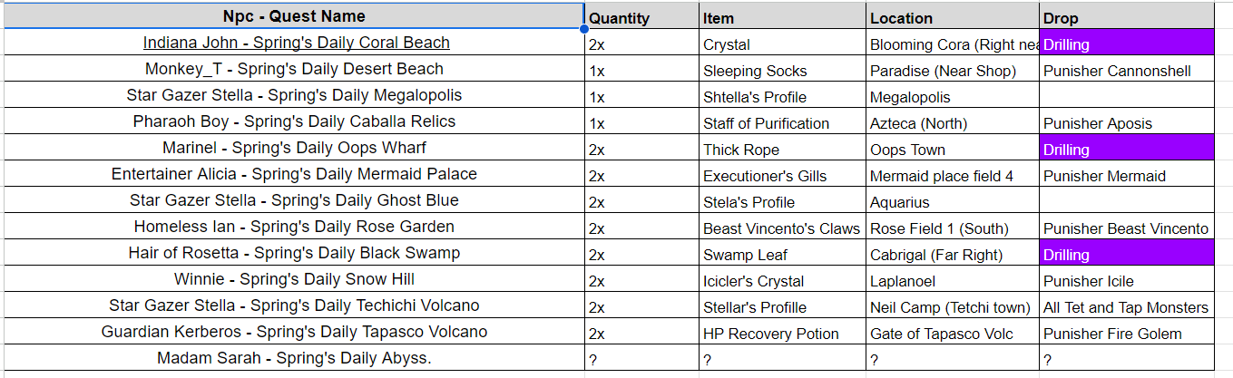

### The Exchanges:

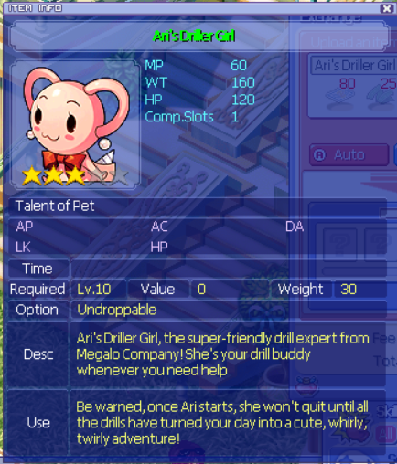

**Ari’s Driller Girl** (15 days): *AFK Driller Pet* - 80x Daily Coupons; 25x [Green Lace](https://wikimirror.lifeto.co/wiki.ggftw.com/trickster/Green_Lace.html); 10x [Dango](https://oto.fandom.com/wiki/Dango); 10x [Garden Trowel](https://wikimirror.lifeto.co/wiki.ggftw.com/trickster/Garden_Trowel.html)

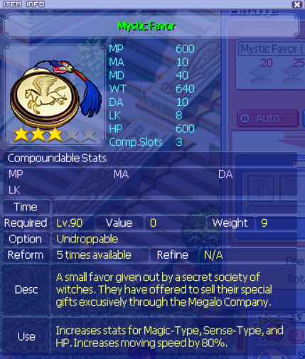

**Mystic Favor** (15 days) : *lv 90 Sprint* - 20x Daily Coupons; 25x [Seal’s Beard](https://wikimirror.lifeto.co/wiki.ggftw.com/trickster/Sea_Tiger.html); 25x [100g Coupons](https://wikimirror.lifeto.co/wiki.ggftw.com/trickster/100_Galder_Coupon.html); 10x [Rice Cake Wrap](https://oto.fandom.com/wiki/Rice_Cake_Wrap)

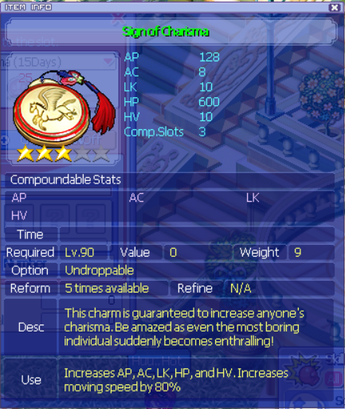

**Sign of Charisma** (15 Days) : *lv 90 Sprint* - 20x Daily Coupons; 25x [Seal’s Beard](https://wikimirror.lifeto.co/wiki.ggftw.com/trickster/Sea_Tiger.html); 25x [100g Coupons](https://wikimirror.lifeto.co/wiki.ggftw.com/trickster/100_Galder_Coupon.html); 10x [Rice Cake Wrap](https://oto.fandom.com/wiki/Rice_Cake_Wrap)

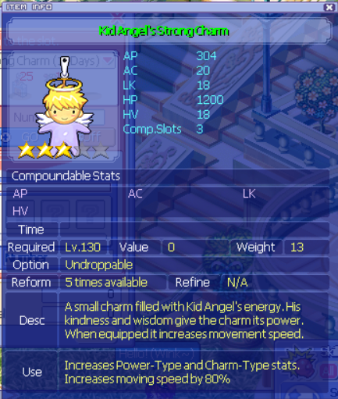

**Kid Angel’s Strong Charm** (15 days) : *lv 130 Sprint* - 40x Daily Coupons; 25x [Fried Egg](https://wikimirror.lifeto.co/wiki.ggftw.com/trickster/Fried_Egg.html); 25x [Empty](https://wikimirror.lifeto.co/wiki.ggftw.com/trickster/Seabed_Field_1_-_North.html) [Liquor](https://wikimirror.lifeto.co/wiki.ggftw.com/trickster/Seabed_Field_2_-_East.html) [Bottle](https://wikimirror.lifeto.co/wiki.ggftw.com/trickster/Seabed_Field_3_-_Undersea_Park.html) ([x](https://wikimirror.lifeto.co/wiki.ggftw.com/trickster/Seabed_Field_4_-_Undersea_Grave.html)); 10x [Ginseng Strawberry](https://oto.fandom.com/wiki/Ginseng_Strawberry)

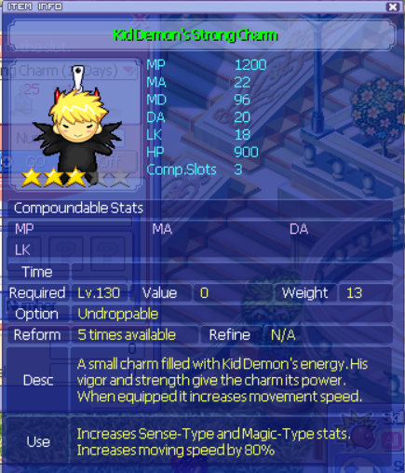

**Kid Angel’s Strong Charm** (15 days) : *lv 130 Sprint* - 40x Daily Coupons; 25x [Fried Egg](https://wikimirror.lifeto.co/wiki.ggftw.com/trickster/Fried_Egg.html); 25x [Empty](https://wikimirror.lifeto.co/wiki.ggftw.com/trickster/Seabed_Field_1_-_North.html) [Liquor](https://wikimirror.lifeto.co/wiki.ggftw.com/trickster/Seabed_Field_2_-_East.html) [Bottle](https://wikimirror.lifeto.co/wiki.ggftw.com/trickster/Seabed_Field_3_-_Undersea_Park.html) ([x](https://wikimirror.lifeto.co/wiki.ggftw.com/trickster/Seabed_Field_4_-_Undersea_Grave.html)); 10x [Ginseng Strawberry](https://oto.fandom.com/wiki/Ginseng_Strawberry)

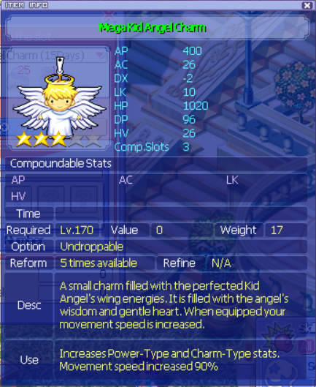  
**Mega Kid Angel Charm** (15 days) : *lv 170 Sprint* - 60x Daily Coupons; 25x [Red Apple](https://wikimirror.lifeto.co/wiki.ggftw.com/trickster/Red_Apple.html); 25x [White](https://wikimirror.lifeto.co/wiki.ggftw.com/trickster/Rose_Field_1_-_Stairway_to_Sorrow.html) [Powder](https://wikimirror.lifeto.co/wiki.ggftw.com/trickster/Rose_Field_2_-_Maze_of_Black_Rose.html) ([x](https://wikimirror.lifeto.co/wiki.ggftw.com/trickster/Rose_Field_3_-_Maze_of_Blue_Rose.html)) ([x](https://wikimirror.lifeto.co/wiki.ggftw.com/trickster/Rose_Field_4_-_Bloom_Grave.html)); 10x [Red Bean Parfait](https://wikimirror.lifeto.co/wiki.ggftw.com/trickster/Red_Bean_Parfait.html)

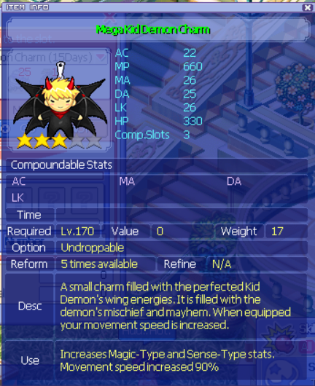

**Mega Kid Demon Charm** (15 days) : *lv 170 Sprint* - 60x Daily Coupons; 25x [Red Apple](https://wikimirror.lifeto.co/wiki.ggftw.com/trickster/Red_Apple.html); 25x [White](https://wikimirror.lifeto.co/wiki.ggftw.com/trickster/Rose_Field_1_-_Stairway_to_Sorrow.html) [Powder](https://wikimirror.lifeto.co/wiki.ggftw.com/trickster/Rose_Field_2_-_Maze_of_Black_Rose.html) ([x](https://wikimirror.lifeto.co/wiki.ggftw.com/trickster/Rose_Field_3_-_Maze_of_Blue_Rose.html)) ([x](https://wikimirror.lifeto.co/wiki.ggftw.com/trickster/Rose_Field_4_-_Bloom_Grave.html)); 10x [Red Bean Parfait](https://wikimirror.lifeto.co/wiki.ggftw.com/trickster/Red_Bean_Parfait.html)

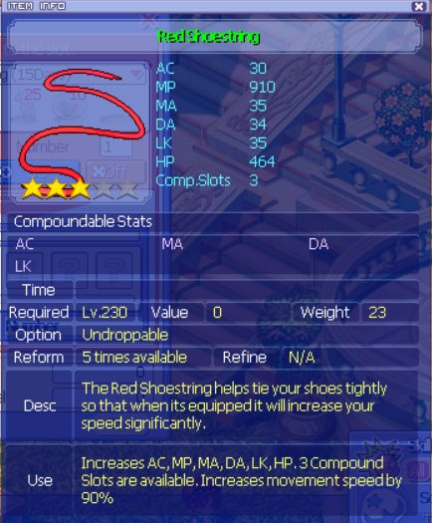

**Red Shoestring** (15 days) : *lv 230 Sprint* - 80x Daily Coupons; 25x [Goma Blanket](https://wikimirror.lifeto.co/wiki.ggftw.com/trickster/Goma.html); 25x [Pottery](https://wikimirror.lifeto.co/wiki.ggftw.com/trickster/Swamp_Field_1_-_Black_Hole.html) [Doll](https://wikimirror.lifeto.co/wiki.ggftw.com/trickster/Swamp_Field_2_-_Beaver%27s_Swamp.html) ([x](https://wikimirror.lifeto.co/wiki.ggftw.com/trickster/Swamp_Field_3_-_Maze_of_Forest.html)) ([x](https://wikimirror.lifeto.co/wiki.ggftw.com/trickster/Swamp_Field_4_-_Dark_Omen.html)) ([x](https://wikimirror.lifeto.co/wiki.ggftw.com/trickster/Swamp_Field_5_-_Further_Maze_of_Forest.html)) ([x](https://wikimirror.lifeto.co/wiki.ggftw.com/trickster/Swamp_Field_6_-_Lake_of_Illusion.html)); 10x [Kimchi](https://oto.fandom.com/wiki/Kimchi)

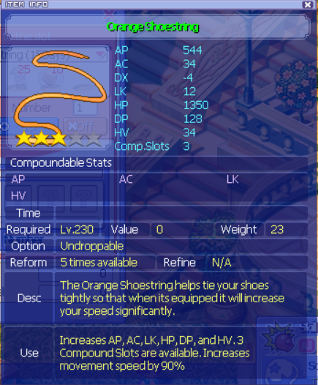

**Orange Shoestring** (15 days) : *lv 230 Sprint* - 80x Daily Coupons; 25x [Goma Blanket](https://wikimirror.lifeto.co/wiki.ggftw.com/trickster/Goma.html); 25x [Pottery](https://wikimirror.lifeto.co/wiki.ggftw.com/trickster/Swamp_Field_1_-_Black_Hole.html) [Doll](https://wikimirror.lifeto.co/wiki.ggftw.com/trickster/Swamp_Field_2_-_Beaver%27s_Swamp.html) ([x](https://wikimirror.lifeto.co/wiki.ggftw.com/trickster/Swamp_Field_3_-_Maze_of_Forest.html)) ([x](https://wikimirror.lifeto.co/wiki.ggftw.com/trickster/Swamp_Field_4_-_Dark_Omen.html)) ([x](https://wikimirror.lifeto.co/wiki.ggftw.com/trickster/Swamp_Field_5_-_Further_Maze_of_Forest.html)) ([x](https://wikimirror.lifeto.co/wiki.ggftw.com/trickster/Swamp_Field_6_-_Lake_of_Illusion.html)); 10x [Kimchi](https://oto.fandom.com/wiki/Kimchi)

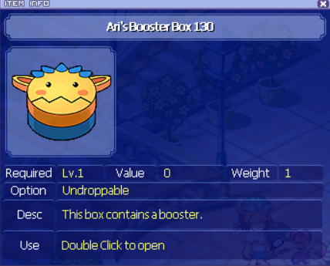

**Ari’s Booster 130** (I do not have the stats on this item; it is not recommended unlike its 210 counterpart) - *rechargeable lv 130 booster* - 20x [Fiesta Marbles](https://wikimirror.lifeto.co/wiki.ggftw.com/trickster/Fiesta_Marble.html); 25x [Old Talisman](https://wikimirror.lifeto.co/wiki.ggftw.com/trickster/Frozen_Corpse.html); 25x [Earplug](https://wikimirror.lifeto.co/wiki.ggftw.com/trickster/Seabed_Field_1_-_North.html) ([x](https://wikimirror.lifeto.co/wiki.ggftw.com/trickster/Seabed_Field_2_-_East.html))([x](https://wikimirror.lifeto.co/wiki.ggftw.com/trickster/Seabed_Field_3_-_Undersea_Park.html))([x](https://wikimirror.lifeto.co/wiki.ggftw.com/trickster/Seabed_Field_4_-_Undersea_Grave.html)); 10x [Takoyaki](https://wikimirror.lifeto.co/wiki.ggftw.com/trickster/Takoyaki.html)

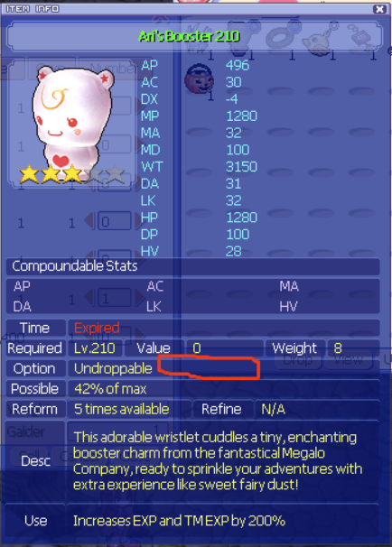

**Ari’s Booster 210** (??? days; also unsalable): *rechargeable booster for lv 210* - 35x [Fiesta Marbles](https://wikimirror.lifeto.co/wiki.ggftw.com/trickster/Fiesta_Marble.html); 25x [Bugbear Doll](https://wikimirror.lifeto.co/wiki.ggftw.com/trickster/Bug_Bear.html); 25x [Grass-leaf Doll](https://wikimirror.lifeto.co/wiki.ggftw.com/trickster/Grass-Leaf_Doll.html); 10x [Vegetable Rice Bowl](https://wikimirror.lifeto.co/wiki.ggftw.com/trickster/Vegetable_Rice_Bowl.html)

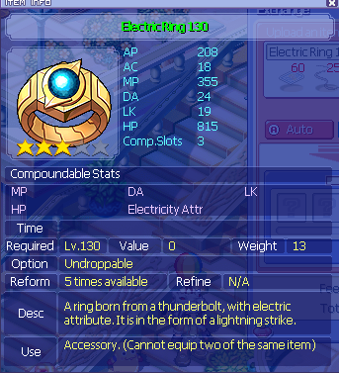

**Electric Ring 130 (15 days)**: *Rechargeable lv 130 attribute ring/accessory* - 60x Daily Coupons; 25x [Copper Hair](https://knowledge.lifeto.co/items/10368); 25x [Emerald](https://wikimirror.lifeto.co/wiki.ggftw.com/trickster/Gate_of_Ghost_Blue.html) ([x](https://wikimirror.lifeto.co/wiki.ggftw.com/trickster/Rose_Field_1_-_Stairway_to_Sorrow.html))([x](https://wikimirror.lifeto.co/wiki.ggftw.com/trickster/Underground_Dev_Room_-_Underground_Passage.html))([x](https://wikimirror.lifeto.co/wiki.ggftw.com/trickster/Gate_of_Black_Swamp.html))([x](https://wikimirror.lifeto.co/wiki.ggftw.com/trickster/Tapasco_Boss_Room.html)); 10x [Pan Fried Noodle](https://oto.fandom.com/wiki/Pan_Fried_Noodles)

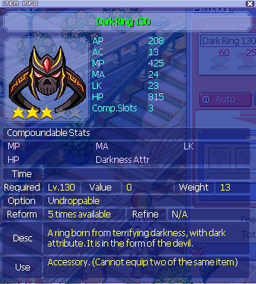

**Dark Ring 130 (15 days)**: *Rechargeable lv 130 attribute ring/accessory* - 60x Daily Coupons; 25x [Old Talisman](https://wikimirror.lifeto.co/wiki.ggftw.com/trickster/Frozen_Corpse.html); 25x [Emerald](https://wikimirror.lifeto.co/wiki.ggftw.com/trickster/Gate_of_Ghost_Blue.html) ([x](https://wikimirror.lifeto.co/wiki.ggftw.com/trickster/Rose_Field_1_-_Stairway_to_Sorrow.html))([x](https://wikimirror.lifeto.co/wiki.ggftw.com/trickster/Underground_Dev_Room_-_Underground_Passage.html))([x](https://wikimirror.lifeto.co/wiki.ggftw.com/trickster/Gate_of_Black_Swamp.html))([x](https://wikimirror.lifeto.co/wiki.ggftw.com/trickster/Tapasco_Boss_Room.html)); 10x [Pan Fried Noodle](https://oto.fandom.com/wiki/Pan_Fried_Noodles)

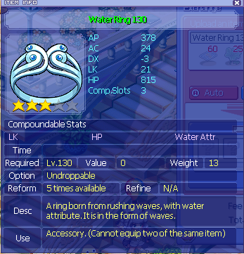

**Water Ring 130 (15 days)**: *Rechargeable lv 130 attribute ring/accessory* - 60x Daily Coupons; 25x [Lotus Leaf](https://wikimirror.lifeto.co/wiki.ggftw.com/trickster/Lotus_Leaf.html); 25x [Emerald](https://wikimirror.lifeto.co/wiki.ggftw.com/trickster/Gate_of_Ghost_Blue.html) ([x](https://wikimirror.lifeto.co/wiki.ggftw.com/trickster/Rose_Field_1_-_Stairway_to_Sorrow.html))([x](https://wikimirror.lifeto.co/wiki.ggftw.com/trickster/Underground_Dev_Room_-_Underground_Passage.html))([x](https://wikimirror.lifeto.co/wiki.ggftw.com/trickster/Gate_of_Black_Swamp.html))([x](https://wikimirror.lifeto.co/wiki.ggftw.com/trickster/Tapasco_Boss_Room.html)); 10x [Pan Fried Noodle](https://oto.fandom.com/wiki/Pan_Fried_Noodles)

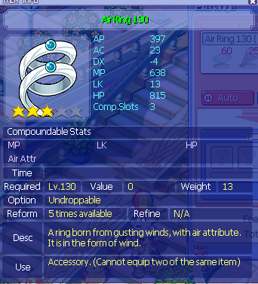

**Air Ring 130 (15 days)**: *Rechargeable lv 130 attribute ring/accessory* - 60x Daily Coupons; 25x [Aristocratic Fan](https://wikimirror.lifeto.co/wiki.ggftw.com/trickster/Aristocratic_Fan.html); 25x [Emerald](https://wikimirror.lifeto.co/wiki.ggftw.com/trickster/Gate_of_Ghost_Blue.html) ([x](https://wikimirror.lifeto.co/wiki.ggftw.com/trickster/Rose_Field_1_-_Stairway_to_Sorrow.html))([x](https://wikimirror.lifeto.co/wiki.ggftw.com/trickster/Underground_Dev_Room_-_Underground_Passage.html))([x](https://wikimirror.lifeto.co/wiki.ggftw.com/trickster/Gate_of_Black_Swamp.html))([x](https://wikimirror.lifeto.co/wiki.ggftw.com/trickster/Tapasco_Boss_Room.html)); 10x [Pan Fried Noodle](https://oto.fandom.com/wiki/Pan_Fried_Noodles)

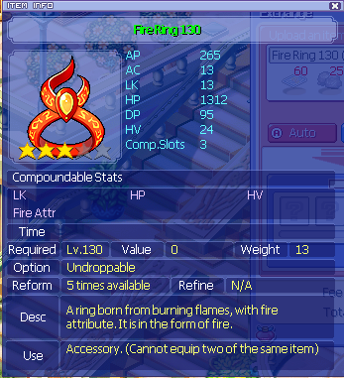

**Fire Ring 130 (15 days)**: *Rechargeable lv 130 attribute ring/accessory* - 60x Daily Coupons; 25x [Coal](https://wikimirror.lifeto.co/wiki.ggftw.com/trickster/Coal.html); 25x [Emerald](https://wikimirror.lifeto.co/wiki.ggftw.com/trickster/Gate_of_Ghost_Blue.html) ([x](https://wikimirror.lifeto.co/wiki.ggftw.com/trickster/Rose_Field_1_-_Stairway_to_Sorrow.html))([x](https://wikimirror.lifeto.co/wiki.ggftw.com/trickster/Underground_Dev_Room_-_Underground_Passage.html))([x](https://wikimirror.lifeto.co/wiki.ggftw.com/trickster/Gate_of_Black_Swamp.html))([x](https://wikimirror.lifeto.co/wiki.ggftw.com/trickster/Tapasco_Boss_Room.html)); 10x [Pan Fried Noodle](https://oto.fandom.com/wiki/Pan_Fried_Noodles)

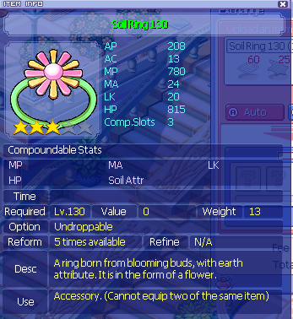

**Soil Ring 130 (15 days)**: *Rechargeable lv 130 attribute ring/accessory* - 60x Daily Coupons; 25x [Swamp Shark Leather](https://wikimirror.lifeto.co/wiki.ggftw.com/trickster/Swamp_Shark_Leather.html); 25x [Emerald](https://wikimirror.lifeto.co/wiki.ggftw.com/trickster/Gate_of_Ghost_Blue.html) ([x](https://wikimirror.lifeto.co/wiki.ggftw.com/trickster/Rose_Field_1_-_Stairway_to_Sorrow.html))([x](https://wikimirror.lifeto.co/wiki.ggftw.com/trickster/Underground_Dev_Room_-_Underground_Passage.html))([x](https://wikimirror.lifeto.co/wiki.ggftw.com/trickster/Gate_of_Black_Swamp.html))([x](https://wikimirror.lifeto.co/wiki.ggftw.com/trickster/Tapasco_Boss_Room.html)); 10x [Pan Fried Noodle](https://oto.fandom.com/wiki/Pan_Fried_Noodles)

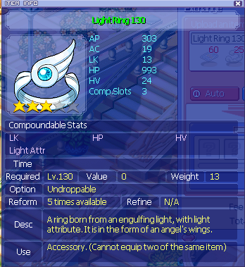

**Light Ring 130 (15 days)**: *Rechargeable lv 130 attribute ring/accessory* - 60x Daily Coupons; 25x [Silk Thread](https://wikimirror.lifeto.co/wiki.ggftw.com/trickster/Silk_Thread.html); 25x [Emerald](https://wikimirror.lifeto.co/wiki.ggftw.com/trickster/Gate_of_Ghost_Blue.html) ([x](https://wikimirror.lifeto.co/wiki.ggftw.com/trickster/Rose_Field_1_-_Stairway_to_Sorrow.html))([x](https://wikimirror.lifeto.co/wiki.ggftw.com/trickster/Underground_Dev_Room_-_Underground_Passage.html))([x](https://wikimirror.lifeto.co/wiki.ggftw.com/trickster/Gate_of_Black_Swamp.html))([x](https://wikimirror.lifeto.co/wiki.ggftw.com/trickster/Tapasco_Boss_Room.html)); 10x [Pan Fried Noodle](https://oto.fandom.com/wiki/Pan_Fried_Noodles)

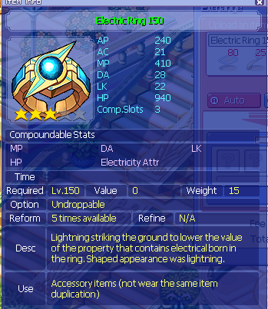

**Electric Ring 150 (15 days)**: *Rechargeable lv 150 attribute ring/accessory* - 80x Daily Coupons; 25x [Feeler Eyes](https://wikimirror.lifeto.co/wiki.ggftw.com/trickster/Feeler_Eyes.html); 25x [Ruby](https://wikimirror.lifeto.co/wiki.ggftw.com/trickster/Ruby.html); 10x [Vegetable Rice Bowl](https://wikimirror.lifeto.co/wiki.ggftw.com/trickster/Vegetable_Rice_Bowl.html)

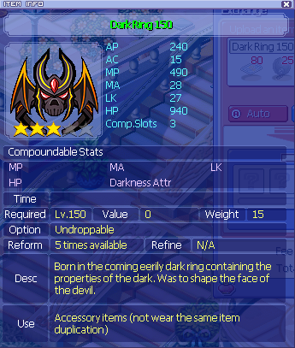

**Dark Ring 150 (15 days)**: *Rechargeable lv 150 attribute ring/accessory* - 80x Daily Coupons; 25x [Black Iron Helmet](https://knowledge.lifeto.co/items/10366); 25x [Ruby](https://wikimirror.lifeto.co/wiki.ggftw.com/trickster/Ruby.html); 10x [Vegetable Rice Bowl](https://wikimirror.lifeto.co/wiki.ggftw.com/trickster/Vegetable_Rice_Bowl.html)

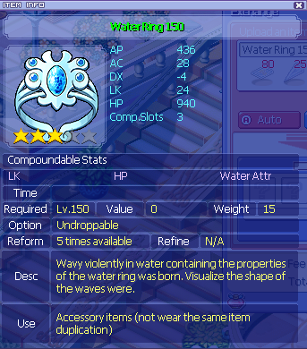

**Water Ring 150 (15 days)**: *Rechargeable lv 150 attribute ring/accessory* - 80x Daily Coupons; 25x [Ice Pick](https://wikimirror.lifeto.co/wiki.ggftw.com/trickster/Ice_Pick.html); 25x [Ruby](https://wikimirror.lifeto.co/wiki.ggftw.com/trickster/Ruby.html); 10x [Vegetable Rice Bowl](https://wikimirror.lifeto.co/wiki.ggftw.com/trickster/Vegetable_Rice_Bowl.html)

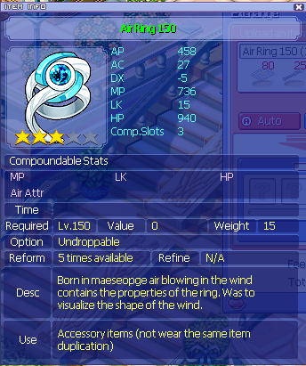

**Air Ring 150 (15 days)**: *Rechargeable lv 150 attribute ring/accessory* - 80x Daily Coupons; 25x [Flute of Gale](https://wikimirror.lifeto.co/wiki.ggftw.com/trickster/Daze.html); 25x [Ruby](https://wikimirror.lifeto.co/wiki.ggftw.com/trickster/Ruby.html); 10x [Vegetable Rice Bowl](https://wikimirror.lifeto.co/wiki.ggftw.com/trickster/Vegetable_Rice_Bowl.html)

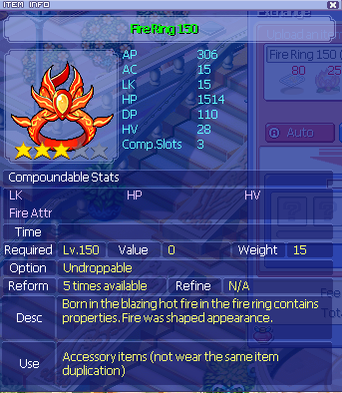

**Fire Ring 150 (15 days)**: *Rechargeable lv 150 attribute ring/accessory* - 80x Daily Coupons; 25x [Fire Flower](https://wikimirror.lifeto.co/wiki.ggftw.com/trickster/Fire_Flower.html); 25x [Ruby](https://wikimirror.lifeto.co/wiki.ggftw.com/trickster/Ruby.html); 10x [Vegetable Rice Bowl](https://wikimirror.lifeto.co/wiki.ggftw.com/trickster/Vegetable_Rice_Bowl.html)

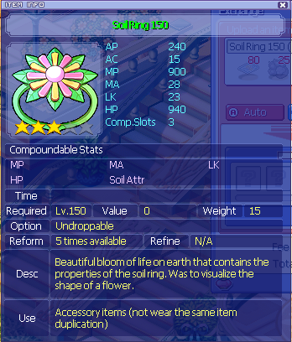

**Soil Ring 150 (15 days)**: *Rechargeable lv 150 attribute ring/accessory* - 80x Daily Coupons; 25x [Kerbero’s Paw](https://wikimirror.lifeto.co/wiki.ggftw.com/trickster/Kerbero%27s_Paw.html); 25x [Ruby](https://wikimirror.lifeto.co/wiki.ggftw.com/trickster/Ruby.html); 10x [Vegetable Rice Bowl](https://wikimirror.lifeto.co/wiki.ggftw.com/trickster/Vegetable_Rice_Bowl.html)

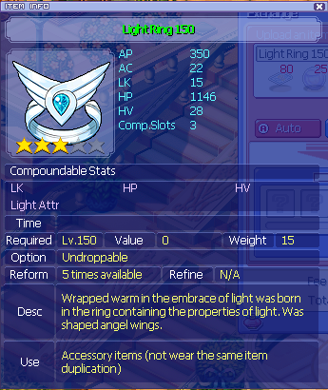

**Light Ring 150 (15 days)**: *Rechargeable lv 150 attribute ring/accessory* - 80x Daily Coupons; 25x [Holy Water Marble](https://wikimirror.lifeto.co/wiki.ggftw.com/trickster/Holy_Water_Marble.html); 25x [Ruby](https://wikimirror.lifeto.co/wiki.ggftw.com/trickster/Ruby.html); 10x [Vegetable Rice Bowl](https://wikimirror.lifeto.co/wiki.ggftw.com/trickster/Vegetable_Rice_Bowl.html)

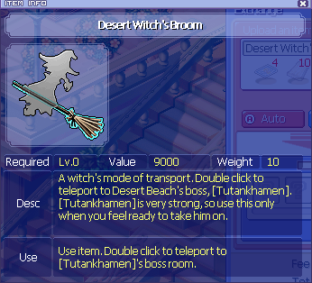

**Desert Witch’s Broom**: *Teleports you directly to Tut’s Boss Room, skipping all trials* - 4x Daily Coupons; 10x [Beeswax](https://wikimirror.lifeto.co/wiki.ggftw.com/trickster/Basic_Mummy.html); 10x [Glyph Stone](https://knowledge.lifeto.co/items/11137)

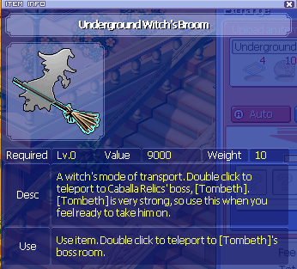

**Underground Witch’s Broom**: *Teleports you directly to Tombeth’s Boss Room, skipping all trials* - 4x Daily Coupons; 10x [Smiling Face](https://wikimirror.lifeto.co/wiki.ggftw.com/trickster/Smiling_Face.html); 10x [Bead Necklace](https://knowledge.lifeto.co/items/11102)

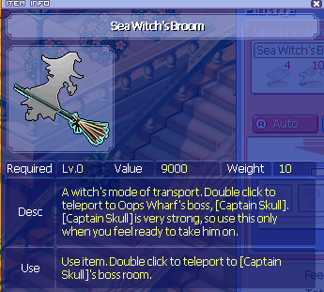

**Sea Witch’s Broom**: *Teleports you directly to Captain Skull’s Boss Room, skipping all trials* - 4x Daily Coupons; 10x [Golden Eyepatch](https://wikimirror.lifeto.co/wiki.ggftw.com/trickster/Golden_Eyepatch.html); 10x [Galetea Statuette](https://wikimirror.lifeto.co/wiki.ggftw.com/trickster/Galatea_Statuette.html)

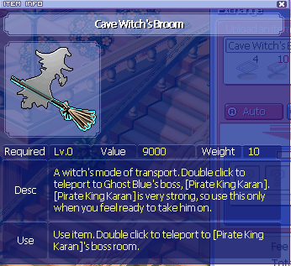

**Cave Witch’s Broom**: *Teleports you directly to Karan’s Boss Room, skipping all trials* - 4x Daily Coupons; 10x [Mini-battery](https://wikimirror.lifeto.co/wiki.ggftw.com/trickster/Plug_Bat.html); 10x [Emerald](https://wikimirror.lifeto.co/wiki.ggftw.com/trickster/Gate_of_Ghost_Blue.html) ([x](https://wikimirror.lifeto.co/wiki.ggftw.com/trickster/Rose_Field_1_-_Stairway_to_Sorrow.html))([x](https://wikimirror.lifeto.co/wiki.ggftw.com/trickster/Underground_Dev_Room_-_Underground_Passage.html))([x](https://wikimirror.lifeto.co/wiki.ggftw.com/trickster/Gate_of_Black_Swamp.html))([x](https://wikimirror.lifeto.co/wiki.ggftw.com/trickster/Tapasco_Boss_Room.html))

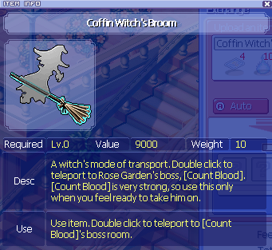

**Coffin Witch’s Broom**: *Teleports you directly to Count Blood’s Boss Room, skipping all trials* - 4x Daily Coupons; 10x [Bone Magician’s Soul](https://wikimirror.lifeto.co/wiki.ggftw.com/trickster/Bone_Magician%27s_Soul.html); 10x [Castle Map](https://wikimirror.lifeto.co/wiki.ggftw.com/trickster/Castle_Map.html)

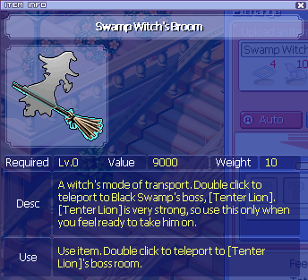

**Swamp Witch’s Broom**: *Teleports you directly to Tenter’s Boss Room, skipping all trials* - 4x Daily Coupons; 10x [Poison Spore](https://wikimirror.lifeto.co/wiki.ggftw.com/trickster/Poison_Spore.html); 10x [Mud](https://wikimirror.lifeto.co/wiki.ggftw.com/trickster/Mud.html)

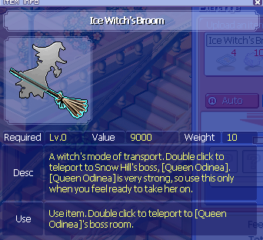

**Ice Witch’s Broom**: *Teleports you directly to Odenia’s Boss Room, skipping all trials* - 4x Daily Coupons; 10x [Dry Ice](https://wikimirror.lifeto.co/wiki.ggftw.com/trickster/Dry_Ice.html); 10x [Luxurious Blanket](https://wikimirror.lifeto.co/wiki.ggftw.com/trickster/Luxurious_Blanket.html)

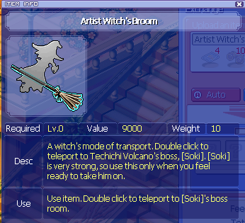

**Artist Witch’s Broom**: *Teleports you directly to Soki’s Boss Room, skipping all trials* - 4x Daily Coupons; 10x [Relic of Ash](https://wikimirror.lifeto.co/wiki.ggftw.com/trickster/Relic_of_Ash.html); 10x [Black Volcanic Ash](https://wikimirror.lifeto.co/wiki.ggftw.com/trickster/Black_Volcanic_Ash.html)

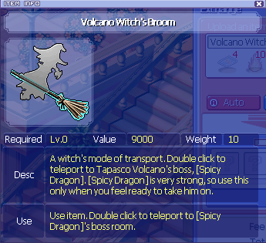

**Volcano Witch’s Broom**: *Teleports you directly to Spicy Dragon’s Boss Room, skipping all trials* - 4x Daily Coupons; 10x [Red Fire](https://wikimirror.lifeto.co/wiki.ggftw.com/trickster/Red_Fire.html); 10x [Pupa of Tiger Moth](https://wikimirror.lifeto.co/wiki.ggftw.com/trickster/Pupa_of_Tiger_Moth.html)

# 

## Eternal Tickets & Eternal Exchanges

### General Info

* Eternal Tickets are an exchange item that allows you to purchase current rotation MyShop Boxes, Character Boxes, and Episode Quest Reward boxes at **Compounder Nadia** in Mega Shop
* The number of tickets required per box varies based on the box’s level and type

### How to Obtain

* Eternal Tickets have a rare % of dropping from every monster; this % rises with harder areas
* You will most likely come across these while grinding or questing along your journey
* You also can obtain these via episode quests

### Character Box Exchanges per Level

* Lv 30: 3 tickets
* Lv 50: 3 tickets
* Lv 70: 5 tickets (3 for Paula)
* Lv 90: 5 tickets
* Lv 120: 5 tickets
* Lv 140: 20 tickets
* Lv 150: 20 tickets
* Lv 180: 20 tickets
* Lv 190: 40 tickets
* Lv 210: 40 tickets
* Lv 230: 40 tickets

### Eternal Boxes

* Refine/Compound/Pet/Port/Misc: 15 tickets each

Scroll down for the contents of each Eternal Box

#### 

#### 

#### Contents of each Eternal Box:

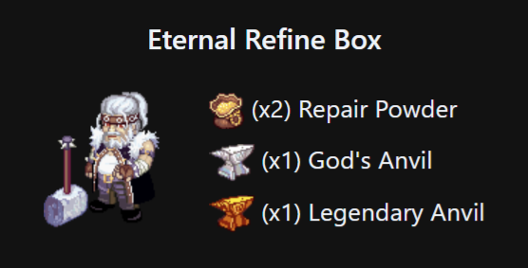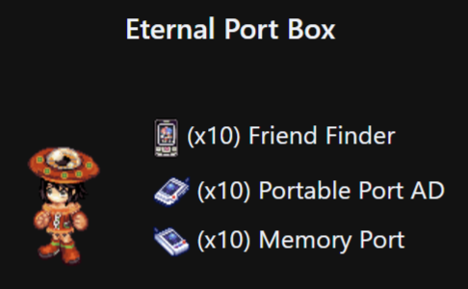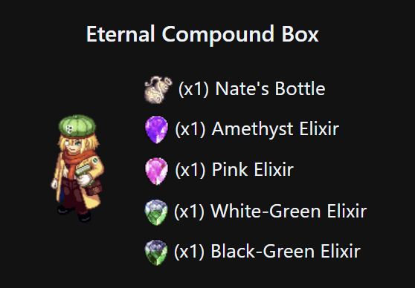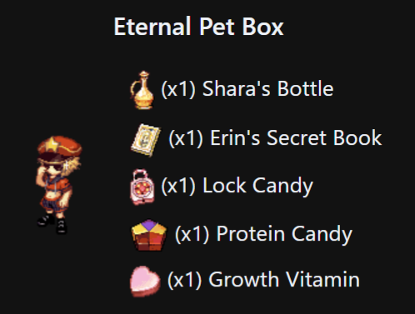

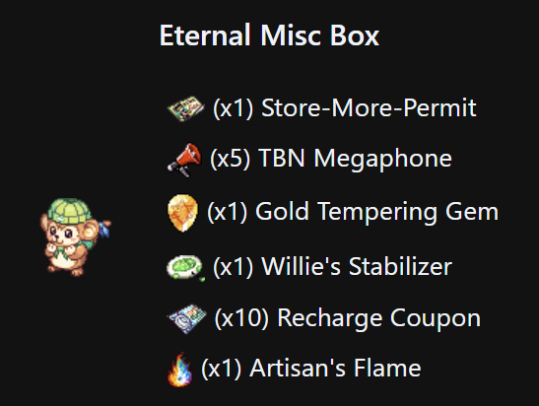

**Eternal Recovery Box:**

* Hyperium Potion Pink and Blue (HP and MP respectively)
* Flower of Revival

### MyShop Boxes

* Vary based on patch, type, and level (no true distinct pattern; check Compounder Nadia for this patch’s exchange rates)

## Eternal Eggs

* Galder-based gacha boxes that rotate every patch. They contain items such as pets, equips, skills, and fortune cards as well as galder checks.
* They are purchased at any of the four Item Girl/Boy NPCs under the statue in the stalls in Megalopolis
* You can check the contents in the patch notes every patch
* They cost 2mil galder each
* These eggs used to have varied chances, but now every item in the respective egg are equally chanced

vv The NPCs selling Eternal Eggs vv

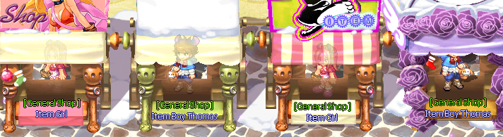

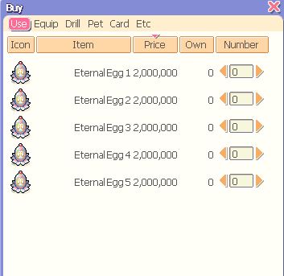 <<<<<<< What each shop looks like

## Eternal Penguins

This is an event that’s reserved to certain patches. This event causes small, robbed pink and blue penguins to spawn in every map (at least one of the two), with a 30 minute cooldown. If they are not killed in a while, they will spawn over and over, as their cooldowns “stack” (this is a bug). Be on the lookout for these penguins! They will also stun you if they get low enough health (after 6 hits), teleport when you approach/lower their health enough, and will always only take 1 damage per hit. They drop something called “*Eternal Penguin Bag 2*”

### Eternal Penguin Bag 2 contents (does not rotate)

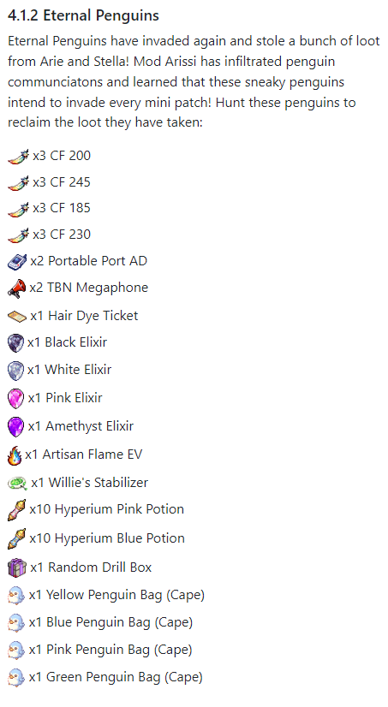

**Please note**: *Penguin Bags* are capes that contain 10k WT with no compoundable slots.

**TIP**: Try to hit them about 6 times–that’s the max you can do without them stunning you. Then, hit them with whatever attacks you have that do multiple hits such as Arrow Rush. It will kill them a lot faster and with less stuns. They have a total of 10 HP or 10 hits worth.

**TIP**: Other skills that will OHKO penguins: Tetra Punch and I believe Hammer Swing from Paula?

**TIP**: If you have a 3 in power on a spare guardian, have them learn Tetra Punch, and they will be a penguin-killing machine.

## Harkon Shard Compound Exchange

### Basic Info

* In this server, you can exchange shards from Harkon Defense for Compound Stones normally acquired through MS
* These NPCs can be found in Event Garden on the left. They look like the first job skill NPCs

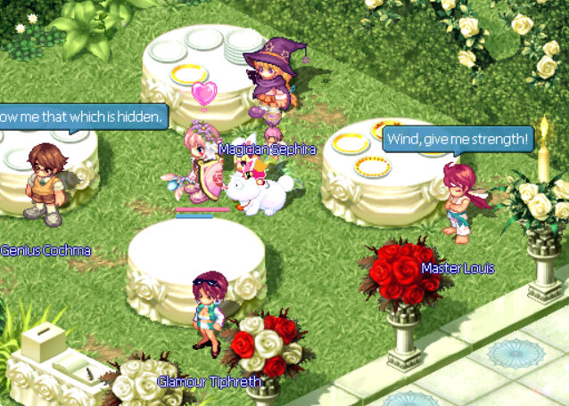

* The exchanges go from Magic Stone 50 to 350
* Magic Stones only require one stone per compound
* You can also get Tokens of a True Trickster on an event-basis, which are high roll compound stones for level 200 up to level 250, and better-than-average compound rolls for up to ~320
* You can exchange a Token at Gate of Alteo (requires guardian + completed episode 5 to go to the area) for a Crest which can be used to compound
* Only one Crest is required for compound
* **TIP**: Crests, Tokens, Magic Stones, and Shards are all tradable! Sell what you don’t need or hoard for secondary/beyond characters!

### Exchanges:

* **Level 50**: 2 Gorgon Shards
* **Level 65**: 2 Gorgon Shards
* **Level 80**: 2 Gorgon Shards
* **Level 95**: 2 Gorgon Shards
* **Level 110**: 2 Gorgon Shards
* **Level 125**: 2 Gorgon, 2 Charybdis Shards
* **Level 140**: 2 Gorgon, 2 Charybdis Shards
* **Level 155**: 2 Gorgon, 2 Charybdis Shards
* **Level 170**: 2 Gorgon, 2 Charybdis Shards
* **Level 185**: 2 Gorgon, 2 Charybdis Shards

**NOTE: Tokens are BIS after this point!**

* **Level 200**: 2 Gorgon, 2 Charybdis Shards
* **Level 215**: 2 Gorgon, 2 Charybdis, 2 Scylla Shards
* **Level 230**: 2 Gorgon, 2 Charybdis, 2 Scylla Shards
* **Level 245**: 2 Gorgon, 2 Charybdis, 2 Scylla Shards

**NOTE: Tokens stop being BIS after this!**

* **Level 260**: 2 Gorgon, 2 Charybdis, 2 Scylla Shards
* **Level 275**: 2 Gorgon, 2 Charybdis, 2 Scylla Shards
* **Level 290**: 2 Gorgon, 2 Charybdis, 2 Scylla Shards

**NOTE: If you are PvE and want to save Hectate shards, Tokens still work for better-than-average rolls on slots up until this point rather easily.**

* **Level 305**: 2 Gorgon, 2 Charybdis, 2 Scylla, 2 Hectate Shards
* **Level 320**: 2 Gorgon, 2 Charybdis, 2 Scylla, 2 Hectate Shards
* **Level 335**: 2 Gorgon, 2 Charybdis, 2 Scylla, 2 Hectate Shards
* **Level 350**: 2 Gorgon, 2 Charybdis, 2 Scylla, 2 Hectate Shards
* **Token of a True Trickster**: 2 Gorgon, 2 Charybdis, 2 Scylla, 2 Hectate Shards

## Website Features

### Account

* **Recharge**: Pay real life money for MyShop points
* **Guild**: Join/manage/view a guild
* **Change password**: Self-explanatory

### Game

* **Disconnect Acc**. : Disconnects your character, good if you accidentally get kicked off the client and it says in your launcher that you are already signed in to the game still
* **Move Character**: Moves your character back to Cora; good if you’re on a map that is overfilled or bugged (shows “Move to main menu” or “Exit Game” Esc. screen but not the Continue button; won’t load the whole map; etc.) and need to get out
* **Move Storage Items**: Moves 10 items from your Lisa Bank to your inventory; used when you activate the storage bug by having too many items in your bank for a self-fix; **MAKE SURE TO HAVE AT LEAST 11 SLOTS IN YOUR INVENTORY**!!!

### Market

* **Buy MyShop**: Spend galder to buy myshop points (must have the galder in the website Bank!)
* **Buy Galders**: Spend MyShop to buy galder (galder goes to your website Bank)
* **Create Listing**: Self-explanatory
* **History**: View your past transactions
* **Bank**: Website-based galder storage, specifically for Market Transactions

#### How to pay with MS for an ingame item (MS trade):

***This is very odd to explain so please pay attention.***

* Say you are buying a Heart Face Paint from someone for 5k MS (not its real price dw); AKA you are giving someone 5k MS for an ingame item
* **Make sure to get a screenshot of confirmation that you will get this item for the myshop points, in case something goes wrong!**
* The person that has the Heart Face Paint (MS recipient) goes to **Market > Bank** with their character OFFLINE and deposits 10,000 galder, then goes to **Market > Create Listing**

**Scroll down for remaining instructions**

* MS Recipient (person with Heart Face Paint) lists a GALDER listing for 10,000 galder (no comma) and 5,000 MS

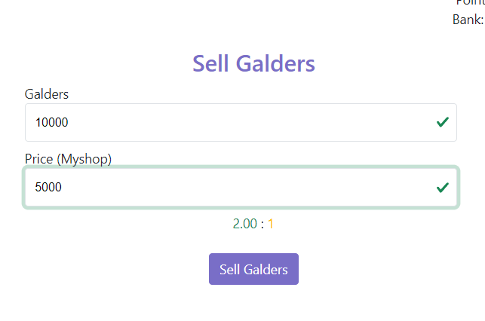 Like this

* That same person goes to **Market >** **Buy Galder** and takes a picture of their listing with their IGN blocked out where you (the buyer of the item/seller of MS) are to “buy” the galder, or shows the listing under the **Create Listing** header where they can delete it
* You, the buyer of the item/seller of MS go to **Market > Buy Galder** and buy the listing that the MS recipient posted with your character OFFLINE
* You have successfully paid in MS!

### QoL

* **NPC Drills**: LOG OFF FIRST!!! Allows you to sell all drills in your inventory with 0 life other than flicker drills

### Event

* Rotates based on event, but you can view details here. You’ll see it mentioned in the patchnotes.

## Faded Tower - WIP

Coming soon….

## Anticipated Path of Progression:

* Get town sets from each area (the sets that require exchange items in each town, other than Paradise, such as the Caballa Slates for Neo Caballa Gear, usually with Mint in each town)
* Get 3rd using town sets
* Quest as long as you can (I like to stop at the end of Ghost Blue), doing Episode Quests up until Episode 3, Chapter 1
* Climb CT until you are 180+
* Spend saved Eternal Tickets on closest level character boxes
* Guardian Prep (Grind cards and galder for cards)
* Guardian Questline+Build (See my guide on that, too!)
* Harkon Defense farming for Eternal Tickets and Shards
* CT Grinding/Quests/Fiesta/Dailies in CT from then-on
* At 200ish, go to Techichi and do the Ancient Site Excavations–you will gain about 30 levels this way. Be sure to have your guardian summoned for it to gain the XP, too!
* At 250ish, you should be near your final stages of equipment, prior to Koi equips. I would start going HAM on tempering/compounding/refining at this stage, especially since you don’t know when/if you will get your hands on the koi equip(s) you need.
* Use shards to exchange for Crests which can then be used for near max rolls on gear up until about level 250 but can be used easily for better-than-average rolls up to 290, where compound stones go higher, but is it worth the gamble from then-on? Up to your pockets and how deep they go, and whether RNGesus is with you.
* Hunt Koi until you get Koi Ring
* If you are a Paula: Hunt Kronos until you get a Kronos Ring
* When you obtain either ring, sell for more money than you can dream of
* **OR**:
* Rinse, repeat, with a new character, at any point! Divvy up your play style and have dedicated characters for things, such as one for farming, one for bossing, one for storage/selling, etc. Make a whole zoo!

## 

## FastLaneTM Method of Leveling to 3rd:

* Do NORMAL Quests up until Ghost Blue, skipping Poppuri Dungeon and Oops Warf in their entirety, but including Mermaid. You will easily get to 130 by the time you do about 6-7 NPCs in Ghost Blue, before Nora Sewer but including the town and fields.
* To get to Mermaid without Oops, use a PPD to get to Oops Town and then buy Diving Gear to get to Mermaid Gate
* **Do not do Key Quests**!!! You will be wasting a lot of time for a completionist route.
* If you are gaining less than 70%ish XP per cycle (each time you hand in a quest for reward), you are in the wrong area!! Go to the next town ASAP!!
* For each area I like to end at:  
  - ***Paradise***: 45 (Move on to Caballa Gate) (<https://wikimirror.lifeto.co/wiki.ggftw.com/trickster/Category_Desert_Beach_Quest.html>)

- ***Caballa***: 77 (you will need to start with specific quests in Mermaid to advance) (do 10 cycles of TM quests here) (<https://wikimirror.lifeto.co/wiki.ggftw.com/trickster/Category_Caballa_Relics_Quest.html>)

- ***Mermaid***: 95~101 (depends on whether or not I hand in 2 drilling quests or not) (do 5 cycles of TM quests here) (<https://wikimirror.lifeto.co/wiki.ggftw.com/trickster/Category_Mermaid_Palace_Quest.html>)

- ***Ghost Blue***: 127~130 (<https://wikimirror.lifeto.co/wiki.ggftw.com/trickster/Category_Ghost_Blue_Quest.html>) (Harkon quest in Snow [<https://wikimirror.lifeto.co/wiki.ggftw.com/trickster/Blacksmith_Marx_-_Find_Ingredients_for_Precious_Jewel.html>] easily covers remaining levels for third job) (do 5 cycles of TM quests here in GB)

- Get Harkon from ***Snow Hill*** <https://wikimirror.lifeto.co/wiki.ggftw.com/trickster/Blacksmith_Marx_-_Find_Ingredients_for_Precious_Jewel.html> . Make sure to have the Quest in your questlog for optimal drilling rates in the mines!

- You get the Ticket of Valiant in your 130 *System Mail Rewards* *(click to go back to section!)*

- The rest of this is mirrored in the 3rd job wiki steps except for [Paula](https://oto.fandom.com/wiki/3rd_job_Advancement#Zoologist_) and [Dark Lord](https://wikimirror.lifeto.co/wiki.ggftw.com/trickster/New_Dark_Lord_Job_Advancement.html) <https://wikimirror.lifeto.co/wiki.ggftw.com/trickster/Third_Job_Advancement.html>

- Grind galder at the nearest “Path to X” you can OHKO at

- If you are a [Paula](https://oto.fandom.com/wiki/3rd_job_Advancement#Zoologist_), your stone is a *Red Ruby* (same as Champion for Bunny), but your NPC is the girl on the dolphin/whale (**Breeder Mimi**) and will be found in *Rose Garden Field 3* on the right.

- If you are going [Dark Lord](https://wikimirror.lifeto.co/wiki.ggftw.com/trickster/New_Dark_Lord_Job_Advancement.html), your stone is *Tiger’s Eye* and *Titanium Fragments*, NOT Alexandrite and Adamantite, but your NPC (**Magician Louie**) is in Mermaid Dungeon 2. <https://wikimirror.lifeto.co/wiki.ggftw.com/trickster/Blacksmith_Marx_-_Light_Alexandrite.html>

- From that point on, you will be in CT and fiesta until 400, depending on how much you can stand the quests.

- My method does not cover Episode Quests! If you do Episode Quests, you will need less time in normal quests for each area, but you *will* need to travel to Oops Warf a lot. If you do decide to do Episode Quests, use a PPD to get to Oops Warf then use Pachi to get to the Gate of Oops and Register there with Kochi. Easy access. I do not recommend doing past Episode 3, Chapter 1 until you are above level 200 or highly geared!

## 

## How to Grind Galder

***Please note: There is currently no way to AFK for money on this server.***

### When you first start:

* *Dailies* are a good way to get your first few checks for 2nd job! You can do the dailies in Paradise, Azteca, and Mermaid Palace to obtain both a daily coupon and a 100k galder check.
* **Paradise:** 1 Sleeping Sock from Punisher Cannon Shell ; NPC: Monkey_T
* **Azteca**: 1 Staff of Purification from Punisher Aposis ; NPC: Pharaoh Boy
* **Mermaid Field 4**: 2 Executioner’s Gills from Punisher Merman Ale ; NPC: Entertainer Elicia

### Buffed farming areas:

* Most “Path to….”s have increased spawns and galder drops

#### **The following fields are affected:**

* Path to Desert Beach
* Path to Caballa Relics
* Path to Phantom School
* Path to Ghost Blue 1 and 2
* Path to Black Swamp
* Path to Snow Hill
* Path to Techichi Volcano 1 and 2
* Tapasco Field 1

### Recommendation:

* There’s two avenues you can pick for easy galder grind at a high level, which is CT 62 or Tap 1 at max level. I prefer CT since you just have to pick up the galder and not worry about the items, but lower galder rate (~8mil/hr). Some people prefer Tap 1 due to the items’ additional value and a higher galder rate (10-15mil/hr).
* Grinding galder for 3rd job might be easier at Path to Ghost Blue 1 and 2, Path to Black Swamp or Path to Snow Hill, depending on how you are geared.
* If you do not like to keep grinding out on the same map, try to fill a server niche with demand for things, such as exchange items for Ari’s Exchange, skill mastery cards, or more, depending on what else you grind! The world is almost just about your oyster, but keep in mind that there are some things the market is not a fan of purchasing.

### Ways to NOT grind galder:

* **Regular cards**–they are only worth 15-50k a piece on this server (I dare you to try to sell for more. Unless you know they have a certain application i.e. Skull Accessory Quest, Weird Box opening, they *will not move*). You want to go after Card Mastery cards instead, which are worth 250-500k a piece, with Paula’s Abyss cards going for about 1-2mil each.
* **AFK Drilling in the mines**–they are not buffed here with nerfed WT unlike other servers.
* **Selling gift boxes to other players**–there is nothing particularly valuable in the level up gift boxes, booster boxes (which a rechargeable one for free can be obtained via Ari’s Exchange instead), or the like that make the boxes themselves a lucrative sell. The most precious items you get from System Mail are things such as the Temper Gem, Elixirs, and Altiverse boxes, which you most likely will use on yourself above selling to other players.
* **Selling items obtainable that patch**–chances are, you will get a better price if you save for a few patches (selling the next patch over usually doesn’t sell as well/at all) or near the end of the patch, but not at the beginning or middle.
* **Willy-nilly buying MyShop boxes to sell their pets or equipment**–you want to check the items’ temper ranges ahead of time to see if they are valuable. Pets tend to have a poor return-on-investment (ROI) so it’s not advisable to roll for them unless you really want them.

## How to Gear/Compare Gear per Patch

### My Recc. for First Characters:

* For as long as you possibly can stand, you’ll want to use town sets and town gear–they’re buffed here!
* A comped set of Mermaid Gear (or mix of Mermaid and Ghost Blue) can easily pass 3rd job trials
* Best results, I have found: Town gear to Ghost Blue (about lv 130) -> climb CT and grind a small bit on CT 44+fiesta -> Get to about 190 for next level character boxes.
* In my opinion, don’t go for the 120-150 boxes if you can help it. Paulas will struggle with this compared to other classes.
* If you skipped the 120-150 boxes, you should have enough for your 190-ish boxes to gear up almost fully and move on to phase 3 of playing, which is grinding galder for cards for Guardian to prep for Harkon Defense to farm more Eternal Tickets.

### With each Patch:

* Keep an eye out for the temper ranges of each item for your desired stat. There will always be an optimal path for the stat at any given time thanks to the character boxes, however, some stats come similar to them and can be a good supplement in a pinch or an upgrade.

#### For example (outdated–All Character boxes are 3s and are always available so this is not an efficient comparison; will change later):

* 3s Sheep Cape 210 (pictured below; considered the meta build cape for sheep) has a range of 15~52 MA, but it is hard to obtain from character boxes, as character boxes are 2~4 slots (*UPDATED INFORMATION: character boxes are now guaranteed 3s!*)

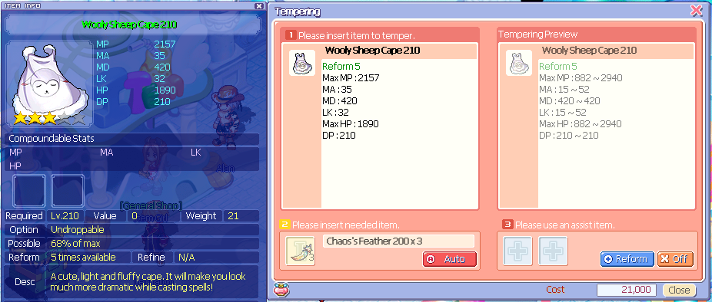

* 3s Hello Kitty Cape 180 (pictured below) has a range of 13~45 MA, but is easier to obtain from Hello Kitty boxes, and are guaranteed 3 slots.

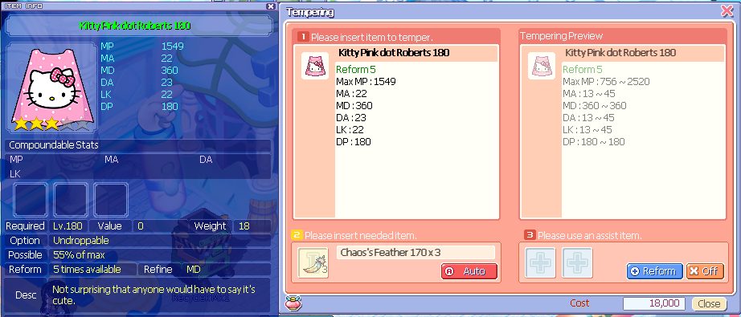

* In this example, you shave a few points off of a potential max roll (that, let’s face it, were we really going to get? *UPDATED ANSWER: Yes! Character boxes are guaranteed 3s!*) for compounding, but the equips are comparable and the Hello Kitty cape is a good cape in a pinch compared to the (*EDIT: previously*) harder to obtain Sheep Cape 210, even at 3s, meaning the bit you lose by shaving off the max few points can be compensated and improved upon with a compound, as opposed to a potential 2s Sheep Cape 210 (which is what you are more likely to encounter *EDIT: until now!*)

## 

## Custom Fuses

One thing specific to the server is custom fuses! The ones in rotation can be found in MyShop > Special Box, or via Events.

**NOTE**: This is also available on the Discord under #faq! *Last Updated: 3/21/24*

**Remember**: Ctrl+[Scrollwheel] or [plus or minus keys] = zooming in/out!

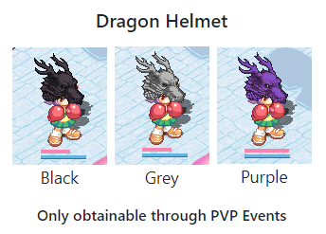

**Dragon Helmet; PvP Event exclusive**

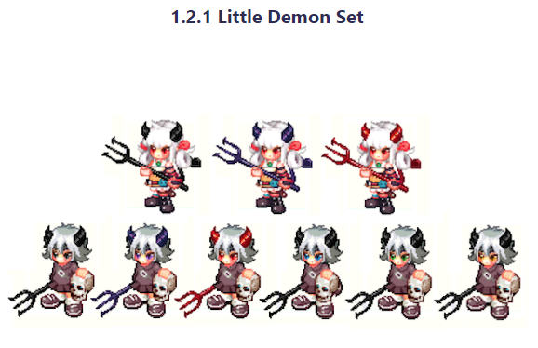

**Little Demon Set; created by former Mod Yuki; MS Box**

* Little Demon Face
* Little Demon Horn
* Little Demon Trident Hammer
* Little Demon Trident
* Little Demon Tail
* Little Demon Skull Shield

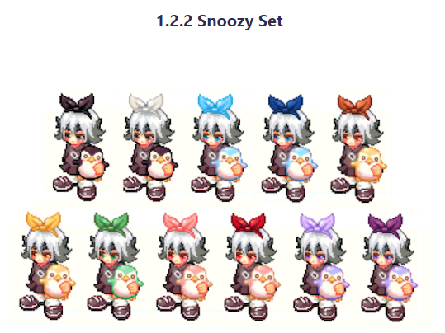

**Snoozy Set; Created by former Mod Yuki; MS Box**

- Snoozy Ribbon

* Snoozy Penguin
* Snoozy Face

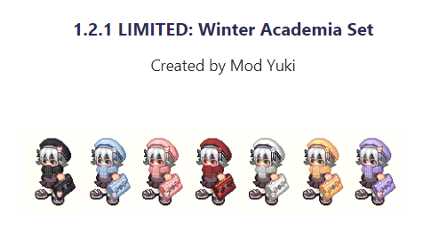

**Winter Academia Set; MS Box (separated by color)**

* Pleading Face
* Winter Academia Beret
* Winter Academia Scarf
* Winter Academia Suitcase

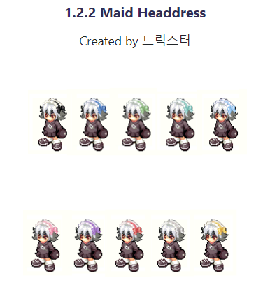

**Maid Headdress; MS Box Only (separated by color)**

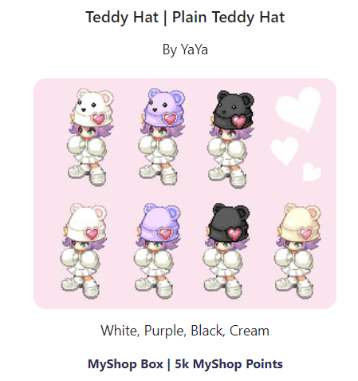

**Teddy Hat & Plain Teddy Hat; MS Box (separated by plain/faced)**

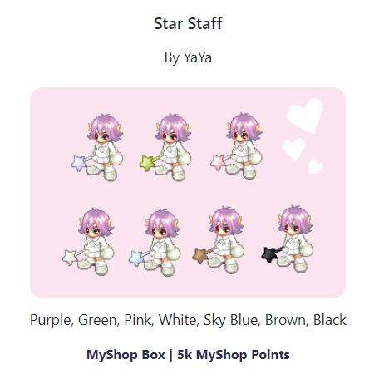

**Star Staff; MS Box**

**Scroll down!**

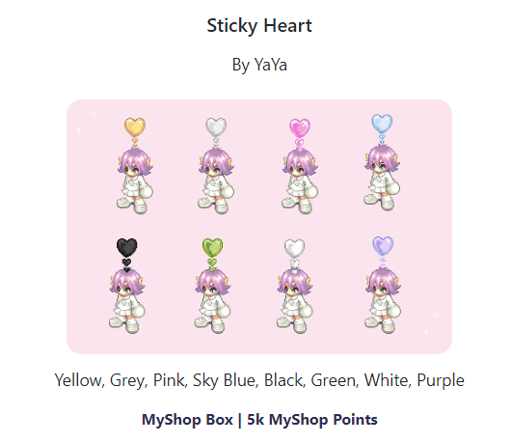

**Sticky Heart; MS Box**

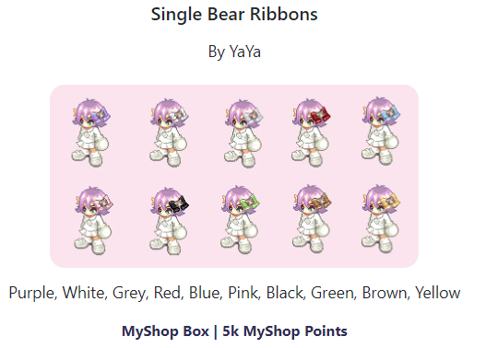

**Single Bear Ribbons; MS Box**

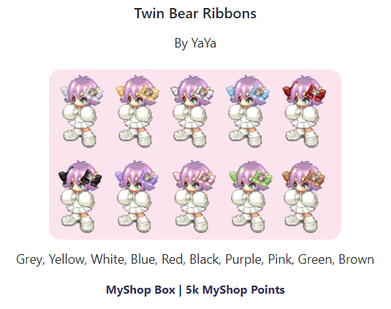

**Twin Bear Ribbons; MS Box**

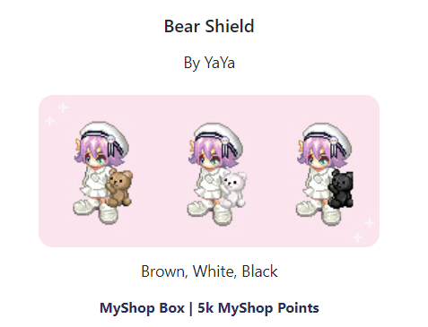

**Bear Shield; MS Box**

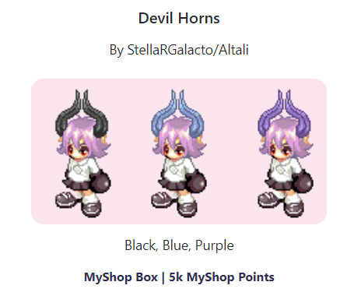

**Devil Horns; MS Box**

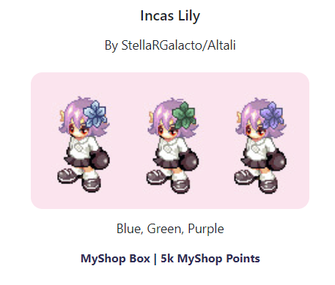

**Incas Lily; MS Box**

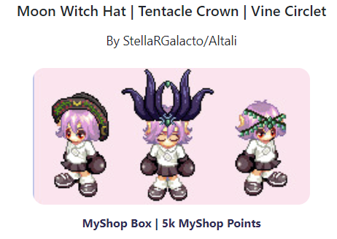

**Eldritch Fuse Box ; MS Box**

* Moon Witch Hat
* Tentacle Crown
* Vine Circlet

# 

**Love’s Joy; Created by YaYa; Event Item**

* Love’s Joy
* Love’s Trust
* Love’s Pain

**Scroll down for more!**

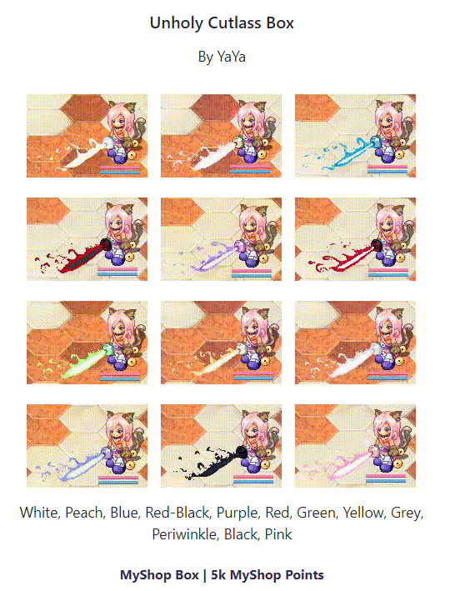

**Unholy Cutlass Box; MS Box;** [**animated**](https://www.eternalpaula.com/patch/240303)

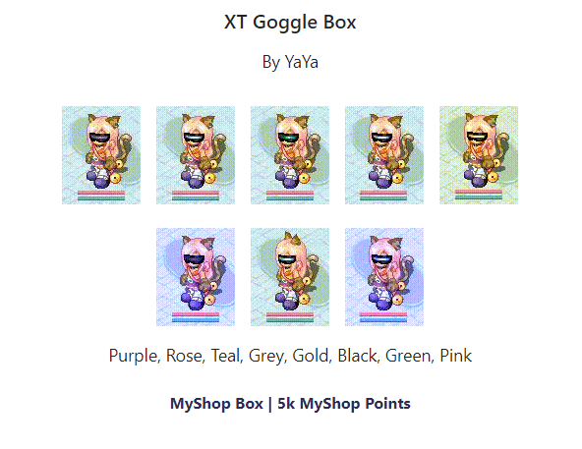

**XT Goggle Box; MS Box;** [**animated**](https://www.eternalpaula.com/patch/240303)

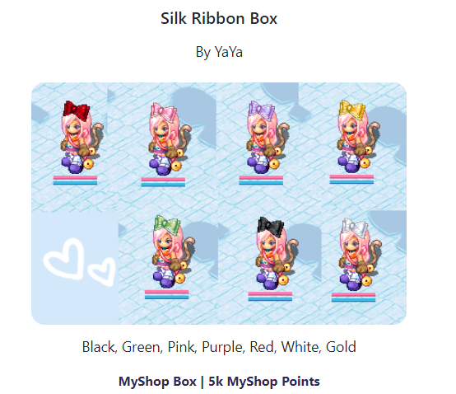

**Silk Ribbon Box; MS Box**

## 

## Custom Fashion

There’s fashion here exclusive to epTO! Most are obtained via MyShop, but some are event-exclusive. *Last Updated: 3/21/24*

**Remember**: [Ctrl]+[Scrollwheel] or [Ctrl] + [plus or minus keys] = zooming in/out!

**White & Black Variants of Fashion Clothing** for all character’s first jobs; Event Item. I have no pictures for this.

### **Sheep**



**First Job Sheep Custom Fashion Sets**

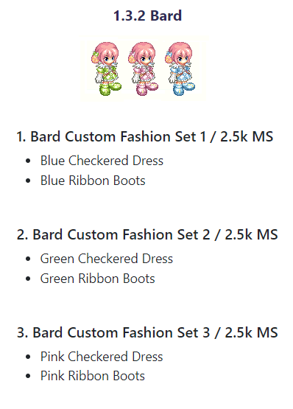

**Second Job Sheep Custom Fashion Sets**

Bard Custom Fashion Set 1

Bard Custom Fashion Set 2

Bard Custom Fashion Set 3

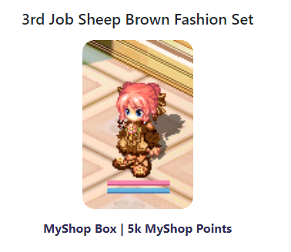

**3rd Job Sheep Brown Fashion Set**

### **Bunny**



**Bunny First Job Fashion Sets**

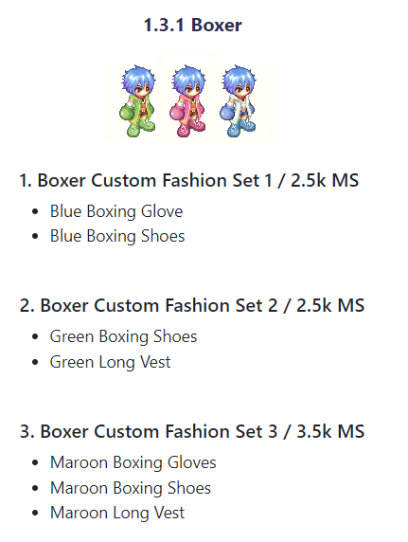**Bunny Second Job Fashion Sets**

Boxer Custom Fashion Set 1

Boxer Custom Fashion Set 2

Boxer Custom Fashion Set 3

Scroll Down

**Cat - Entertainer**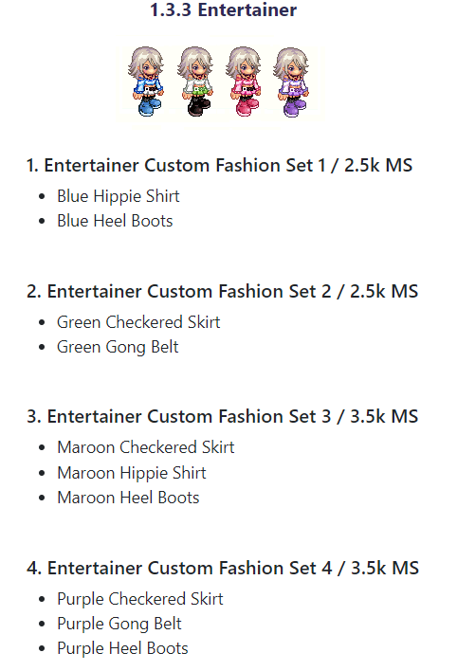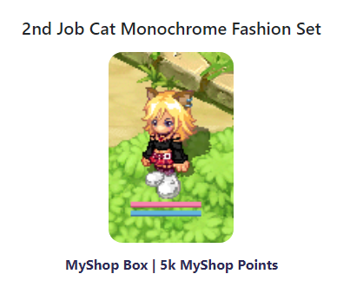

**Scroll down!**

**Buffalo - All 3rd Jobs**

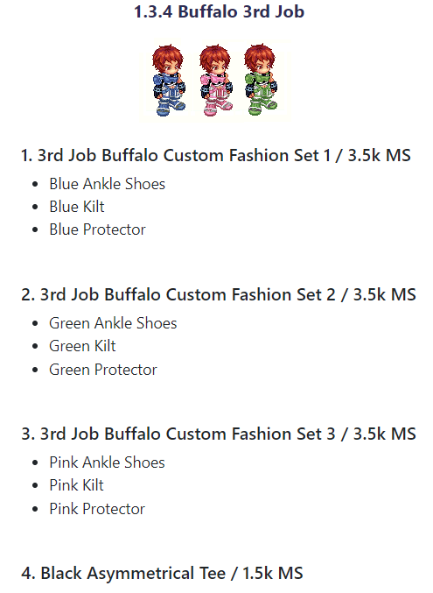

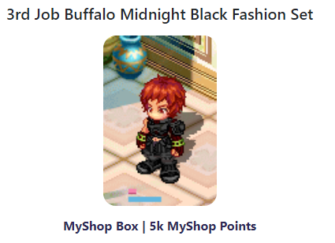

**Fox - All 3rd Jobs**

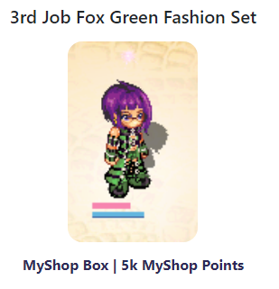

**Dragon - All 3rd Jobs**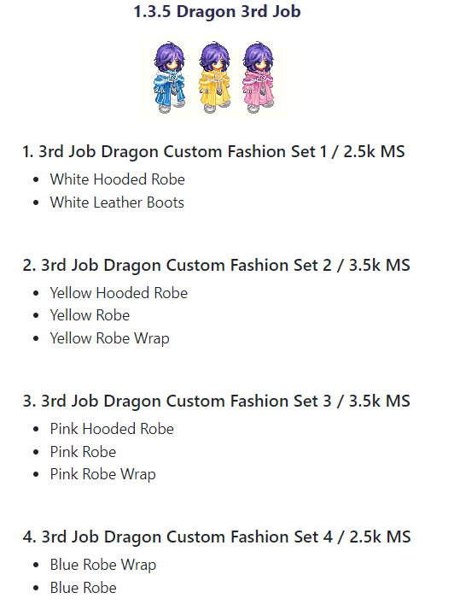

**Raccoon - Card Master**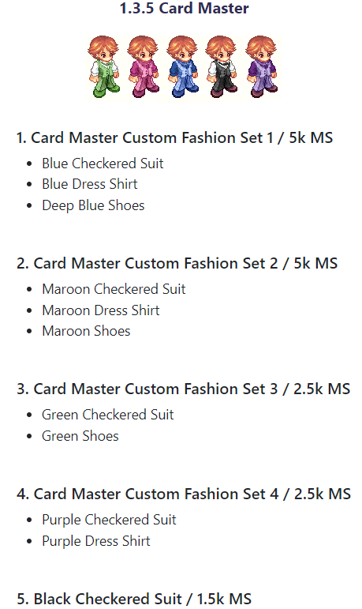

# General Trickster Knowledge

Now that you’re versed in server-specific features, here’s general knowledge for you, in case you need it.

## 

## Controls and Secret Controls

vv Here’s a basic guide to most key commands vv

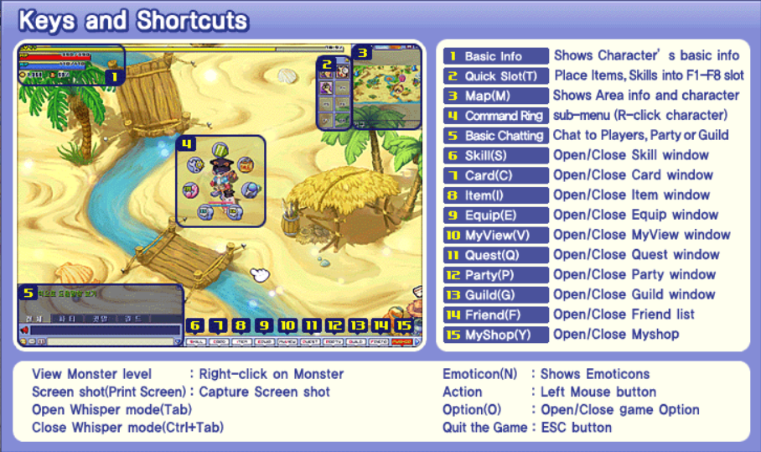

### Other Controls:

**Alt** : Brings up clickable captions on monsters and items on the floor–may lag your client, depending on how many there are

**Alt+[1-4]** : Quick changes chat tab

**Ctrl+[#]** : Quick chat registry command, 0-9 works; change with /Register [#]

**D**: Drill

**H key** : Brings up chat rooms that anyone can access from any safe zone

**Pg up/down**: sit/sleep/stand up. Sitting heals faster, and sleeping heals the fastest.

**R**: Run/Walk

**RClick another Player**: Opens up command window for a variety of interactive options

**Shift+Click on screen**: Orient your character to a specific direction (where you click)

**Shift+Click on text**: Copies the text

**Z**, **J**, or **~ key**: Pickup items

### Some Commands (case-sensitive):

**/Angry** : Angry emote

**/answer [x or o]** : Only works in the O/X booth in Paradise; allows you to teleport people on the opposite letter. Use wisely!

**/Connection [player name]** : Sees if a player is online (i.e. /Connection Mewzie)

**/Depth** : Check drilling depth of a map

**/Energy** : Energy Emote

**/Happy** : Happy Emote

**/help** : brings up help text you see when first connecting

**/Help** : brings up the infographic located here

**/Macro** : Shows what you have registered for your registry keys

**/Map** : Tells you the full name of the map you’re located in

**/Notice [mesage]** : Write a notice, with more letters than normal Rclick character > Notice allows

**/Register [#] [message]** : Change the quick chat registry message (i.e. /Register 1 Hello!)

**/Sad** : Sad Emote

**/sit** : sits or stands up

**/Sleep** : sleeps, only works when sitting

**/Time** : Shows the ingame time (also able to be seen by hovering over the sundial above your minimap)

## 

## Drilling

### Basic Info

- Drilling is a super important feature in Trickster! You complete quests, receive exclusive items, and more using this feature

- You learn about drilling with Driller Marky in Gate of Desert Beach, but in case you missed/overlooked/skipped the dialogue, this section is for you!

- Some areas such as towns and specific fields do not allow drilling

- There are 4 types of pre-drilling messages: A lightbulb that tells you that an item is there, a "squiggle tile" which tells you an item is NOT there, no message at all (only there when you do NOT have 90 DA), and a "Surprise" (used for specific quests and Poseidon's Treasure/Treasure Hunting/"Maps" that you drill up in each area [explained here (COMING SOON!)])

- You can AFK drill using a Driller Boy from MyShop, or Ari's Driller Girl from the Ari's Exchange, explained here

### How to Drill

- You press D to drill and click a spot and it will react a specific way that will either allow you to drill or not allow you to drill

- You need drills in order to drill. You can either buy these from MyShop (very good, especially Flickers)

- Once you find a spot you can drill in, left click and hold anywhere on the screen. You want to raise the yellow bar to the first line you see and keep it inbetween that line and the edge of the drilling bar. Don't worry, as long as you don't right click, your character will not move. Right clicking cancels drilling at any point.

- Quick image of what it looks like when you drill:

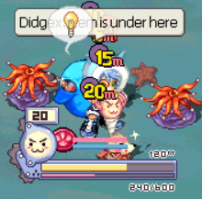 < This is when you know there’s an item under, mid-drill, past the line

- If you press D to drill, you will be in Driller Mode (basically, wherever you click affects drilling) until you Right Click, even if you run out of drills

- You can tell how much life you have using the pink bar or the number at the bottom left

- You can tell the max depth of your drill with the number at the top right of the drill bar

- The number at the top left above the crazy driller meter (explained in the next section) is the depth you’re currently drilling at

### Crazy Drilling

- Crazy drilling is a skill learned via a questline in Paradise speaking to Marky, Reina, and John at the top left edge of Paradise over by the portal to Field 4.

- These quests involve various drilling and killing, however, it is relatively easy to obtain

- You can only access Crazy Drilling by filling up your "anger" meter, located at the left on the >:3 circle. It fills up with red as you find items, and even more when you either do not find an item or receive an "item is not here" message.

- If you activate Crazy Driller Mode (automatically done when you reach a certain threshold based on the drill; shown the progress by the anger meter), you can instantly drill underneath where you click, either revealing an item or showing nothing.

- **TIP**: If you activate Crazy Driller Mode, click like crazy!

### Tips

- To avoid the "no message at all" and guarantee either a lightbulb or a squiggle tile, have **90 DA**.

- You may need a drilling set, depending on the character and level, to obtain 90 DA. My suggestion is Vulpine Character Boxes, where most/all items give some sort of DA and can be compounded for more.

- If you are a Paula, Paula Character Boxes also help, but you can't reuse the items for other characters as much as you can with Vulpine Boxes.

- **Another tip**: if you find an item, chances are, there are more items to the immediate directions around you or nearby. Items tend to "spawn" in clusters/around the same area in "spots"

- **TIP**: If you are a sense character, do not learn the Item Detection skills and do not buy the Item Detection scrolls. They go to a limited depth which do not help later on in game and use up valuable recycle tickets and skill points that could be used for something else.

## Important NPCs and Their Functions

 **Mint** - Equipment exchange NPC in each town; get town sets with this NPC using specific quest rewards (i.e. Caballa Slates, Mermaid Scales, Spirit Marbles, etc.) based on the town.

 **Compounder Paul** - Compound various materials (quest items and otherwise); sometimes replaced or alongside **Compounder Nadia**.

**WARNING**: The % chance on these compounds are not always the same every time, so try to check compound rates several times to see what is max for you (press auto to list your items then go but don’t accept the next dialogue box).

**Lovely Angelina and Banker Lisa** - Bank NPCs; Angelina’s storage can be expanded to 10 pages, but it is bound by WT determined by the number of slots as well as your level, and it does not share across your account. Banker Lisa’s can be shared across your account and has no WT limit, but a limited… …number of slots. Angelina is known as **Keeper Julio** in Azteca.

**WARNING**: There is a bug associated with Angelina’s storage and using more than 7-8 page’s worth of item slots where every time you use the bank after storing more than 8 pages full (approximately), you disconnect. You will need to submit a support ticket to remove at least one item slot from your bank if this occurs, but please try to stick under the limit, anyway.

**WARNING**: There is a bug with Lisa’s storage and storing galders. It will not let you store more than 99,999,999 galders in the bank.

**Pia** - Recharges your timed items via recharge coupons. Allows you to select the duration via a dropdown menu and apply the coupons with the press of a button.

 **Andrew** - A shopkeeper that allows you to buy certain types of galder checks, which are used for job advancement. If you sell a galder check to this NPC, you will get the value of the check back, unlike Item Girl, where you get only half of its value.

**Louis Bitton** - Allows you to change into the visuals for any job you’ve already unlocked. Does not allow you to change your 3rd job’s job, only the appearance from 1st to 2nd and so on!!!

**Pachi and Kochi** - Teleportation sisters; allows you to quickly teleport to specific checkpoints and towns, depending on where they’re at.

 **Item Girl** - Shop NPC; allows you to sell items to her as well as cards. **WARNING**: Do not sell galder checks or skills to her! Sell galder checks to **Andrew** and spare skills to a **skill-based NPC** (any will do) for your full return. Why waste the money?

**Professor Komby** - Forging NPC; allows you to combine Altiverse gear only; use a Willie’s Stabilizer to change odds from 60% of keeping the secondary item/succeeding the Forge to 100% odds.

**WARNING**: If you refined/compounded one of them, put it in the first slot, or the refine/compound will be lost!

**Pet Trainer Shara** - Allows you to equip/remove hardants, synergize pets, or train pets.

**WARNING**: Synergizing 5 star pets does NOT save any hardants you have, so don’t equip a hardant until you are sure you will not do more modification to the pet other than training.

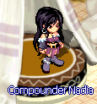**Compounder Nadia** - Allows you to compound in specific towns instead of/in conjunction with **Compounder Paul**. In Megalopolis Shop, she controls the eternal ticket exchange

**WARNING**: The % chance on these compounds are not always the same… …every time, so try to check compound rates several times to see what is max for you (press auto to list your items then go but don’t accept the next dialogue box).

**Blacksmith Marx** - Refine NPC for your equipment; allows you to upgrade a specific stat (outlined with R-Click on any equipment under “Refine”) up to level +13, based on the number of stars the equipment has and an unlisted modifier (not very important for you to math out/know) that ends up with RNG involved; the % is accurate.

 **Alchemist Nate** - Mature Compounding NPC; allows you to add via RNG mechanics or remove mature compounds to your equipment using stones/monster drops to add to the compounds, and a Nate’s Bottle to remove a manually-selected compound.

**Alan** - Tempering NPC; allows you to modify your equipment based on a predetermined stat range (depends on… …the equipment model itself rather than a random range) using RNG mechanics and Chaos Feathers.

**Fusion Master Arlene** - Fuse NPC; allows you to modify the appearance of one item using another via Artisan Flames (also known as Fuse Flames).

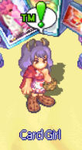 **Card Girl** - Quest NPC, gives you ™ quests based on cards in that area.

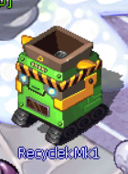**Recycle Machine** - Allows you to recycle MyShop items for tickets that you can exchange for scrolls or character boxes; looks different per map

## 

## Chaos Tower (CT)

### How to start:

Follow along with pictures: <https://oto.fandom.com/wiki/Tower_of_Chaos_Quests>

* **Poirot** (Gate of Caballa), then **Ren** (Gate of Caballa) (Compound Gold Lens= 1xOptical Glass Crystal [Drill] + 1x Animal Bone [Drill]+ 5x Gold [hunt Mimics - Relics Field 2/3/4]; compound at **Compounder Paul** in Azteca)
* **Ren** again (20xExpensive Film = Drill in Relics Fields)
* **Poirot** (Gate of Caballa)
* **Poirot** - Issue Tower of Chaos Entrance Pass (Chaos Tower First Floor–go to Relics Field 1 at the top left, into the portal to CT’s first floor, and then speak to him on the left)
* **Developer Project Manager L** - Issue Tower of Chaos Entrance Pass – top left of CT First Floor
* **Wandering Warrior Tan** (outside Chaos Tower portal–top left of Relics Field 1)
* Kill 50x Mimic (Relics field 2/3/4; these guys look like open red chests with skeleton arms and legs) then go to **Warrior Tan** again via the portal it gives you when you do so
* Kill 30x Naranjo (Relics Dungeon ¾–go to Relics Field 4 and near top right corner is the dungeon portal; these guys look like green and brown-colored boxes with boxes ontop of them), then go to **Warrior Tan** again via the portal it gives you when you do so
* Kill 2x Punisher Aposis (Any Relics Field–look like normal Aposis [snake ladies with ankhs in both hands] but semi-transparent) then go back to **Warrior Tan** via portal
* **Poirot** (CT Floor 1)- Deliver 2nd Floor Survey Notebook

### What to do when you’re there:

* Help **Warrior Tan** every floor starting with CT 2, first quest (Tell him you’re there to help Poirot), to climb the tower.
* On floors you grind on, do the byte quest with **Intern G**, but ONLY floors you are grinding on and not just climbing, otherwise you are wasting your time; also, do the **Warrior Tan** training quests (preferably the Extreme one; it will give more XP for less time) on said floor
* **TIP**: Do not advance past floors you can’t OHKO, or one-hit-knock-out. Or, at least try to get to the nearest safe/grindy (grindy=big, open floors that have more XP/galder, not sure which ones these exactly are other than 36, 44, 48, 56, and 62) floor.
* **Safe Floors**: 1, 7, 13, 19, 25, 31, 37, 43, 49, 55, 61, 67
* **Boss Floors**+Respective **Altiverse** gear ***[format: SafeFloor# (NameOfSet [level of set]****)* : 12 (Spiritual [lv 110]), 24 (Twist [lv 155]), 36 (Flash Bat [lv 200]), 48 (Thorny Rose [lv 245]), 60 (Maiden Queen [lv 290]), 72 (Crimson [lv 335])
* **TIP**: Boss floors are under every OTHER Safe Floor starting from CT 13, for quick access, but to get to Boss 48 and above, you must teleport to 43 first with Pachi.
* **TIP**: You can do bosses twice when you first kill them: their initial kill, and then your daily!
* **TIP**: This is what people mean when they say “*do dailies in CT*”--they are referring to the bosses!
* Every safe floor, speak to **Kochi**, **Pachi** (Floor 24 and above), or the **Machine** (floor 42 and above) and REGISTER for that floor. Do not go without registering!

### How to do Dailies:

* This only applies when you kill each boss for the first time: You can kill the boss twice in one day, once for the initial kill (Which is basically just pressing the “I want to Quest” button every time) and once for the daily. See the next point for how to do the daily itself, which does not change.
* **AFTER** You kill each boss for the first time: Speak to **Poirot** on **Floors 12, 24, 36, 48, 60,** and **72** for your dailies! Start by asking to Quest, and then going to the gap, and killing the boss. When you are done, speak to him about a ***REINVESTIGATION*** on the safe floor that you are teleported to when the boss room crumbles (he will be on the left, except after 72, where he will be in the middle, slightly to the right when you spawn in).
* **TIP**: All Dailies, except for 72, can have you go in them unlimited times, so you can help your friends if you wanted! You just won’t get the daily reward more than once, so be aware of that. 72 can only be entered once per day (but attempted an unlimited amount of times) once won.

#### Easy (and easier) method to going the whole tower for Dailies:

* CT Floor 1 -> Teleport to floor 13
* Use Portal to speak to Poirot on Floor 12
* Kill Floor 12 Boss -> Wait for room to “be destroyed”
* Speak to Poirot about reinvestigation -> Get box
* Teleport to Floor 25
* Repeat process of using the previous portal to go to the boss to teleporting to the next safe floors (36) until you are done with 36.
* Teleport Floor 36 -> Floor 43 -> Floor 49
* Continue process until done with Floor 60 boss and submitted reinvestigation
* Teleport to Floor 69 -> Walk the way to 72 (yes this is the only way)
* Speak to Poirot -> Kill boss -> Wait for room to crumble -> Speak to Poirot again
* You have scaled the whole Tower!
* **Suggestion**: Only do 49->61->60(boss)->69->72(boss) when you’re high level; Maiden and Crimson gear are worth a lot and the rest are only good for when you’re at that level, not for resale value.

### Titles

* In CT, there’s a system called “titles”. These are predetermined cosmetic additions to your name. In order to obtain a title, you must complete the prerequisite quest condition for each. You can find a list of all the titles and their associated quests here: <https://wikimirror.lifeto.co/wiki.ggftw.com/trickster/Titles.html> and here for 61-73 <https://oto.fandom.com/wiki/Titles> (hover over each for more details)
* **Titles grant nothing more than cosmetics**!
* For everything under 12 titles achieved, you get nothing but the titles themselves. After 11 (12+ basically), you obtain a special Mat you can use for your character’s Private Selling Shop!

#### All the Mats & # of Titles Required:

#### How to apply a Mat to your Shop:

* Right Click your character > Private Shop > Mat button > Use Arrow buttons to change between mats. *Scroll down for pictures of how to do this*.
* 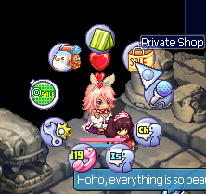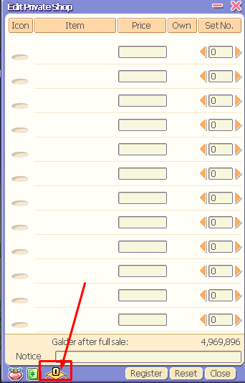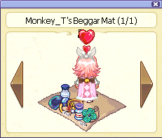
* When you select a Mat, depending on which one you choose, the mat button will change its number to correspond with which mat you use.

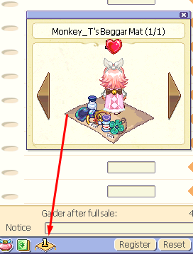 Make sure to register your shop afterwards!

## Refining

### Basic Info

- Refining increases a particular stat for each set of gear (You can see which stat by Rclicking the equip in your Inventory and looking for the "Refine" box)

- You need ores from the mines to achieve this

- You can use Anvils (up to level 11) and Refine Fortune to increase your refine odds

- Physical equipment and Magic equipment use different ores

- Weapons use more stones compared to Shields and Hats

- Mines Snow, Techi, and Tapasco all have Harkons as their final quest reward for Blacksmith Marx! Use this for guardian and 3rd job advancement!

- You can also find the same information listed on this guide here: <https://wikimirror.lifeto.co/wiki.ggftw.com/trickster/Refinement.html>

### Refine Stone Basic Bracket Types

- Level 0-4: Fragment

- Level 5-7: Impure (Physical) and Gem (Magic)

- Level 8-10: Pure (Physical) and Flawless (Magic)

- Level 11-13: Rare ores (Ancient Steel, Moonstone, Mithril, Garnet, Ori-Harkon, Zircon, Adamantite, Alexandrite)

### Mine Locations & Depth

- Desert Beach: Crystal Copper - Desert Field 2; **10~20m**

- Caballa Relics: Jade Steel - Relics Field 3; **50~130m**

- Black Swamp: Silver Jewel - Swamp Field 6; **120~160m**

- Snow Hill: Precious Jewel - Snow Field 2; **180~200m**

- Techichi Volcano: Golden Ash - Techichi Field 4; **185~250m**

- Tapasco Volcano: Silent Lava - Tapasco Field 1; **230~300m**

### Stones in Each Mine & Levels for Refine

##### - Desert Crystal Copper:

- 1st Mining Lot - Physical

- Bronze Fragment/Impure/Pure (lv 1~30)

- Tin Fragment/Impure/Pure (lv 31~50)

- Sulfurous Fragment/Impure/Pure (lv 51~70)

- 2nd Mining Lot - Magic

- Quartz Fragment/Gem/Flawless (lv 1~30)

- Amethyst Fragment/Gem/Flawless (lv 31~50)

- Agate Fragment/Gem/Flawless (lv 51~70)

##### - Caballa Jade Steel:

- 1st Mining Lot - Physical

- Ancient Steel (lv 1~70)

- Lead Fragment/Impure/Pure (lv 71~90)

- Soft Iron, Impure/Pure (lv 91~110)

- Steel, Impure/Pure (lv 111~130)

- 2nd Mining Lot - Magic

- Moonstone (lv 1~70)

- Jasper Fragment/Gem/Flawless (lv 71~90)

- Cat's Eye Fragment/Gem/Flawless (lv 91~110)

- Kunzite Fragment/Gem/Flawless (lv 111~130)

##### - Swamp Silver Jewel:

- 1st Mining Lot - Physical

- Mithril (lv 71~130)

- Silver Fragment/Impure/Pure (lv 131~150)

- 2nd Mining Lot - Magic

- Garnet (lv 71~130)

- Turquoise Fragment/Gem/Flawless (lv 131~150)

##### - Snow Precious Jewel:

- 1st Mining Lot - Physical

- Tantalum Fragment/Impure/Pure (lv 151~170)

- Titanium Fragment/Impure/Pure (lv 171~200)

- Ori-Harkon (lv 131~200)

- Adamantite (lv 201~400)

- 2nd Mining Lot - Magic

- Opal Fragment/Gem/Flawless (lv 151~170)

- Tiger's Eye Fragment/Gem/Flawless (lv 171~200)

- Zircon (lv 131~200)

- Alexandrite (lv 201~400)

##### - Techichi Golden Ash:

- 1st Mining Lot - Physical

- Stibnite Fragment/Impure/Pure (lv 201~240)

- Okenite Fragment/Impure/Pure (lv 241~280)

- Ori-Harkon (lv 131~200)

- Adamantite (lv 201~400)

- 2nd Mining Lot - Magic

- Spinel Fragment/Gem/Flawless (lv 201~240)

- Hyacinth Fragment/Gem/Flawless (lv 241~280)

- Zircon (lv 131~200)

- Alexandrite (lv 201~400)

##### - Tapasco Silent Lava:

- 1st Mining Lot - Physical

- Ori-Harkon (lv 131~200)

- Adamantite (lv 201~400)

- Scolecite Fragment/Impure/Pure (lv 281~320)

- Pyrrhotite Fragment/Impure/Pure (lv 321~360)

- Jadarite Fragment/Impure/Pure (lv 361~400)

- 2nd Mining Lot - Magic

- Zircon (lv 131~200)

- Alexandrite (lv 201~400)

- Chrysocolla Fragment/Gem/Flawless (lv 281~320)

- Jacinth Fragment/Gem/Flawless (lv 321~360)

- Cassiterite Fragment/Gem/Flawless (lv 361~400)

### Refine Charts For How Much You’ll Need:

PLEASE SCROLL DOWN, THANKS!

#### **Physical Weapons**

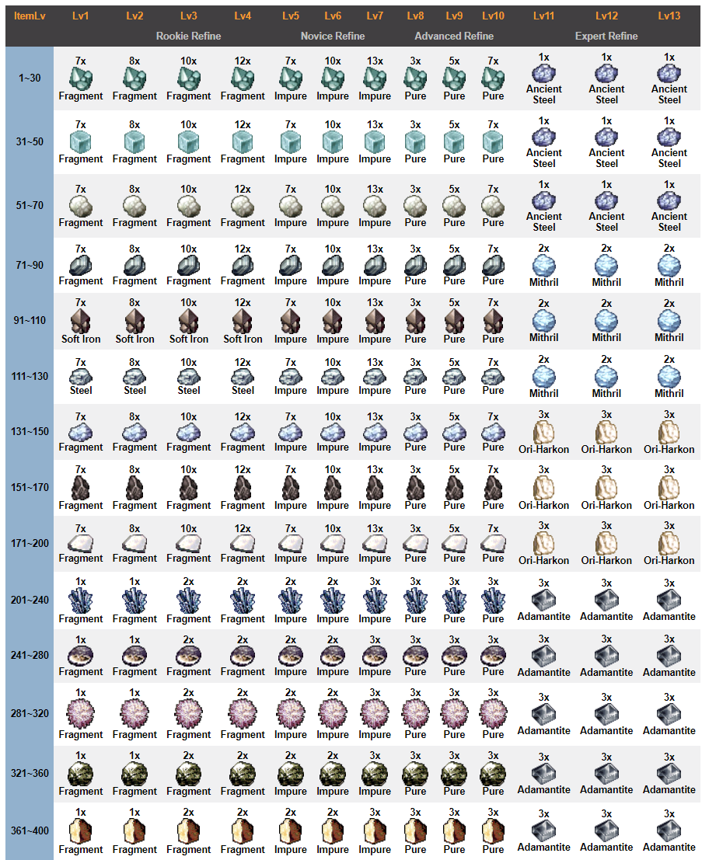

**KEEP SCROLLING!**

#### **Physical Hats and Shields**

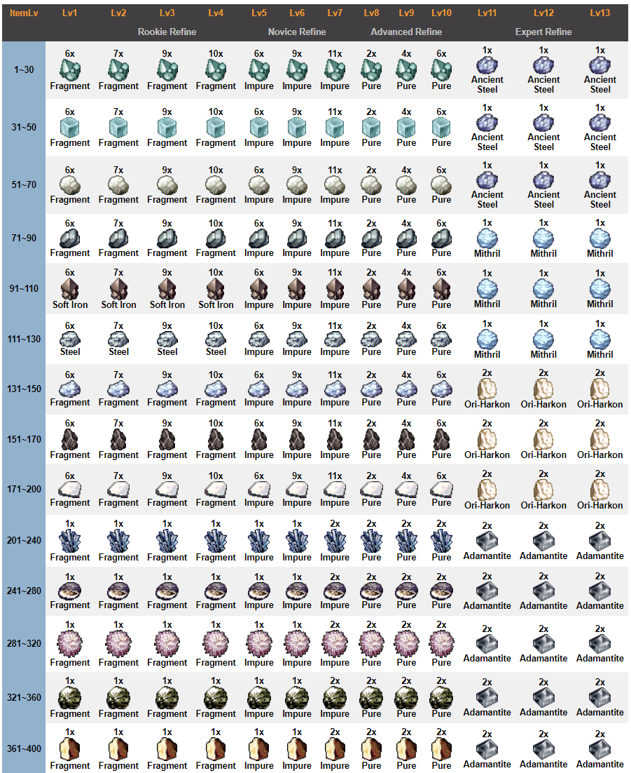

**KEEP SCROLLING!!!**

#### **Magical Weapons**

# 

**KEEP SCROLLING!!!**

#### **Magical Hats and Shields**

## 

## Tempering - WIP

Full version coming soon…

### Basic info:

* Tempering is when you take *Chaos Feathers* to the NPC **Alan** to adjust the values of a specific equip (sword/hat/shield/hammer/staff only), based on a predetermined range based on what the equip is (i.e. a Powerful Regal Shield has the same temper range as another Powerful Regal Shield)

**>Chaos Feather**: item granted by specific Party/Monster Quests as well as Eternal Penguins; used for tempering; requires 3 per temper

* You can use a *Temper Gem* to increase the range of one stat further, up to two stats with two gems

**>Temper Gem**: MS-exclusive item used for tempering; raises the values of the lowest and highest parts of a stat’s range, based on a manual pick; can have up to two temper gems per temper; sometimes an event reward or fiesta exchange

* After 5 tempers, you need an *Alan Bottle* to reset the tempers

**>Alan Bottle**: PREVIOUSLY MS-exclusive item that now can be bought at Item Girl in Mega Shop for 50k; resets temper count so you can retemper

* You can view the temper range by putting the item in the first slot. The temper range will be shown on the right.



## MyShop

### Basic Info

* MyShop is a marketplace where you buy directly from the server’s infinite Type-hammerspace supply of specific items using real life currency, converted to another currency known as “MyShop points” or “MS” for short.
* You can buy or sell MS on the website under the “Market” tab when you log in from or to other players

### Types of Items You Can Buy:

* Gacha Boxes (Special Box; some in New Item)
* Invisible Skins for Equips
* Flicker Drills
* Nate’s Bottles
* Recharge Coupons (BUY ONLY FROM RECOMMENDED ITEM!!!)
* Repair Powder (DO NOT BUY FROM RECOMMENDED ITEM!!! Go to Use > Modifiers instead!!!)
* Artisan’s Flame (Fuse Flames)
* MyShop-exclusive Equipment and Pets
* Driller Boys and their variants (only Driller Boy is worth it for Driller Boys, do not buy another type–their recharge costs do not justify the stats or what you pay for it!!!)
* Drills (Flickers are the best!!!)
* Pet Hardants
* Guardian-related items
* Build Graph Resets (gives all points back and changes your build graph manually)
* Point Back All (gives all points back) and Point Back 40 (only gives back 10 levels’ worth of points)
* Skill Reset Set/Master’s Authority (removes a skill completely, refunding the points used but not the card[s] used)
* Reidentifier 2000 (renames you)
* Elixirs (affects mature compound chances; best is amethyst+pink)
* Pet Stat Modifiers (Growth Vitamin, Lock Candy, Protein Candy, Shara’s Bottle) and other modifiers (Hardants, Secret Books)
* Allen Bottle (DO NOT BUY FROM HERE!!! BUY FROM MEGA SHOP ITEM GIRL INSTEAD!!!)
* Gold Tempering Gems
* Willie’s Stabilizer (used for forging altiverse equipment)
* Anvils (Legendary [lv 8-10]; God [0-8]; the rest are rip-offs)
* Potions (rip-off)
* Scrolls (rip-off)
* Magic Stones (used for mature compounding; also obtainable for free via Harkon Defense shard exchange in Event Garden)
* Hair Dye (you can get hair dye coupons for free from other players or from Eternal Penguins; this is primarily for emergencies IMO)
* Portable Port AD (More indepth PPD); Memory Port (saves up to 5 locations to instantly teleport to that spot); Friend Finder (teleport directly ontop of a friend)
* Store-More Permits (SUPER important; also, there is a bug with your storage at about the 7 page mark where it bugs out and you have to use the website to move items out of your storage because too many are in there)
* TBN Megaphone (broadcasts a message to the whole server; requires Mic) and Mic (broadcasts to the whole map; required to use a TBN)
* Star Tears (extends fortune)
* Time Capsule Ticket (“freeze” a character in a vault so you can free up that character slot; IMO not useful–just make another account)
* Character Slot Expansion Ticket (Add another character slot to your account; there’s a bug after 3 characters [the base amount you’re allowed to have] so DO NOT BUY THIS!!!!)
* Fashion (cosmetics made for your character’s specific job/class; left click on the image to try on)

### Gift/Gifting:

* You can send Gifts in MyShop. To do so, press the Gift button and select your friend’s name from the drop down. Yes, they must be your friend first.
* After you send it, the recipient must click on the gift button, then press “Take Gift” to move it to their MyShop Inventory where they can then move it to their regular inventory

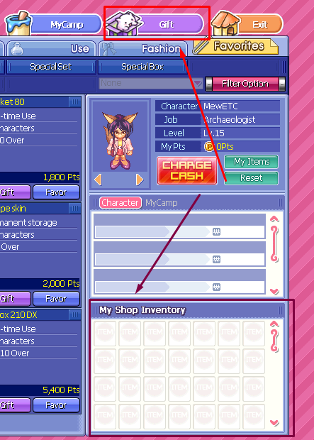

Red = Gift Button

Purple = MyShop Inventory

## MyCamp

### General Info

- MyCamp is a decorative addition to Trickster! Do you like the Sims, where you build and create your own house and decorate it with little intracate details? Or perhaps building in Minecraft? This is like that, but with pre-made assets to choose from

- Most items in MyCamp cost MS, however, as you travel along your Trickster journey, you unlock free items such as chairs, beds, wallpapers, "skins" (exteriors), and more! Check on it once in a blue moon as you level; you may be surprised how many items you can decorate with

- You can enter a MyCamp by double clicking its white textbox above it or clicking on the text that underlines when you hover over it (the title/name)

- Due to code limitations, you can only save one layout per character :(

- If you have MS, feel free to check out this feature to its fullest extent! Just be careful, the amount of points you need to decorate adds up quick!

### How to Set Up Your MyCamp

- Right Click your character and click on the Tent icon at the top right

- It will ask you to name your MyCamp (which will be shown to other players so be careful how you name it!), choose between "Open" (anyone can join) and "Private" (requires a password; you then can set up the password in a newly revealed text box if you select this option), and the limit of how many characters you want to be able to enter the camp (2-16)

- If you enter your MyCamp and click the pencil at the top left under the preview of your exterior MyCamp skin, you can edit the information you just entered, and even secretly make the tent have a much longer title than when you're setting it up normally outside of the MyCamp

### Decorating Your MyCamp

- You can either check out what is in the MyCamp shop/your MyCamp inventory by going to MyShop (press Y) and clicking the MyCamp button at the top right (it will not set up a MyCamp right away; you have to manually do this after saving the layout) or by pressing “Shop” after entering your MyCamp and it will open up the decoration screen where you can edit it or just preview what's in the shop

- If you do decide to preview what's in the shop, don't worry about paying right away--you can preview your layout before you buy or saving your free item placements!

- You can check out the name of the item and how much it costs before placement by double-left clicking the item in the MyCamp Shop (top left window of the decoration screen). Help budget yourself this way!

- Make sure if you plan on buying the items, click the Pink "Shopping" icon next to the name of the item in the Article Manage menu (center left) under the MyCamp shop window (Top left) and above your unused/available MyCamp inventory (bottom left).

- Each item's price is written in the Article Manage menu (center left; inbetween shop and inventory windows) so even if you decide to not right click and view info of everything you're looking at previewing, you can see based on the name of the item (pretty easy to identify/guess) and the price in MS is next to it

- Prices of these items can range from maybe 80 MS (small items) to upwards of 5000 MS (dolls, primarily) each (if you disagree with the dolls'/high-end items' prices, suggest a decrease in the Discord! It would be helpful for other players if you did--it hasn't been made yet :) )

- You can only buy items one at a time, so if you decide you are happy with the items you placed either for that room or in general, make sure to press the shopping bag icon!

- To save the layout after placement and/or purchasing the items, either attempt to exit using the top right, or press the Save button icon (it looks like a Floppy Disc) on the decoration menu screen at the top-left. Make sure to press “OK” when you're doing this to save the layout!

### Types of Items Available in the Store & Descriptions

**Special** - Just a bank that you can use; expires every 7 days

**Space** - Extra Floors, Walls, and Partitions (part of walls)

**BG** - Camp Skins, Skins (Backgrounds), WP (Wallpapers for walls), Stripe WP (accents for walls), Floor (Flooring cosmetics), Window (Cosmetic windows for walls), and Door (Doors for walls, cosmetic)

**Furniture** - Bed, Rack (Various “Shelving”; doesn’t store things), Table, Chair, Furnishing (Cosmetic electronics), Kit/Bath (Kitchen/Bath items)

**Props** - S-Electrns (Small electronics), Wall Deco (Decorations for walls), Floor Deco (Decorations for floors), and Carpet (Small carpets for your floor)

**Set** - Currently empty; used to house sets of similar items in eTO

## 

## Fiesta

### Basic Info

- Fiesta is a zone where every 2 hours, you can enter using a Fiesta Ticket (drilled anywhere, but especially in Gate of Desert Beach)

- These areas give massive amounts of XP for the most part for your level, and scale based on predetermined level brackets

- There are two areas in fiesta: zone 1 (easier to OHKO and not aggro; immediately accessible) and zone 2 (much harder; requires higher end gear to OHKO and monsters are aggro; opens about 10 minutes after the original room opens)

- Fiesta is announced approximately 10 minutes before (this is the earliest you can enter), two minutes before, and then when it starts. It is one of the system message green texts that appears every once in a blue moon while you're online; you probably have seen it or overlook/ignore it (like I accidently do lol)

- Fiesta is open for approximately 30 minutes

- You can go to Fiesta twice a day

- You can also get Fiesta Marbles which are used for an exchange with Heidi in the Waiting Room for various items, and sometimes for MS Consumables or pets that are only around for a mini-patch event

- Sometimes, there are specific Fiesta-related mini patch events for special pets and MS consumables. Be on the lookout with mini patches!

### Level Brackets and Associated Zone Names

* Level **21-59**: Fiesta Zone 1 - Cora Alert
* Level **60-89**: Fiesta Zone 2 - Sand Alert
* Level **90-119**: Fiesta Zone 3 - Cucool Alert
* Level **120-149**: Fiesta Zone 4 - Skull Alert
* Level **150-179**: Fiesta Zone 5 - Jelly Fish Alert
* Level **180-219**: Fiesta Zone 6 - Mask Alert
* Level **220-259**: Fiesta Zone 7 - Mud Alert
* Level **260-299**: Fiesta Zone 8 - Snow Lady Alert
* Level **300-339**: Fiesta Zone 9 - Stone Sculpture Alert
* Level **340-400**: Fiesta Zone 10 - Orc Alert

## 

## Pets

* Obtained from a variety of sources, such as System Mail, Paradise Quests, MyShop boxes, Eternal Eggs, Bonus Egg Shop, and Events.
* Many are MyShop exclusive, so prepare to roll with eternal tickets! They are there for a limited time for most boxes, and have a very low % chance of being rolled.
* Character boxes have a form with increased chances. They are the DX box variants (i.e. Cat Box DX 190), which doubles your chances, but it’s still under 10% of a chance.
* More information here: <https://wikimirror.lifeto.co/wiki.ggftw.com/trickster/Pet.html> (please note that Pet Hunt is not currently available here, nor are pet drinks)

### To compound (“equip hardant”) a pet:

- You need hardants. One *hardant* covers one slot.

**> Hardants**: MS-exclusive “compound” materials specific to a pet. Equipped at the NPC Shara in Megalopolis Shop.

- You can use elixirs with hardants! Try it if you’re feeling lucky

- Most pets are one slot but you get 3 hardants per purchase for multiple attempts

- To attempt multiple times, you need to have a *Shara bottle*

**> Shara Bottle**: MS-exclusive “compound” removal material. Used with [INSERT NPC HERE] in Mega Shop. One bottle covers one slot. Also obtainable via the *Eternal Pet Box*

### To Fuse & Unfuse a pet:

* You need a *Secret Book* to Fuse. This removes the stats permanently on the “image” (or looks/aesthetic/”skin”) pet and applies the looks of the “image” pet to the “stats” pet. You also will obtain a *Goodbye Box*.

**> Secret Book**: MS-exclusive fuse item for pets. Used with [INSERT NPC HERE] in Mega Shop. You can also obtain these with the *Eternal Pet Box*

**>Goodbye Box**: Box obtained only by fusing two pets together, releasing one of its stats permanently. Unsure of its contents, may match lifeTO’s : <https://knowledge.lifeto.co/items/62322>

* You need a *Artisan Flame* to Unfuse

**> Artisan Flame**: MS-exclusive fuse item for pet skin removal and equipment skin application/removal. Also known as a *Fuse Flame*. Used with the NPC Fusion Master Arlene in Mega Shop or Paradise Shop. You can also obtain these via the *Eternal Misc Box*

### To Temper (“Train”) a pet:

* You need a *Protein Candy* to Train. This changes the stats randomly based on a predetermined range, much like equipment tempering, except this is done at **Pet Trainer Shara** in locations such as Mega Shop. You can also use a *Lock Candy* to lock stats so they don’t re-roll.

**>Protein Candy**: MS-exclusive item used for Pets. Used with **Pet Trainer Shara** to temper/”train” pets. Can also be obtained with the *Eternal Pet Box*.

**>Lock Candy**: MS-exclusive item used for Pet training with **Pet Trainer Shara**. “Locks” or freezes a stat so it does not temper upon using a protein candy. Can also be obtained with the *Eternal Pet Box*.

### Pet Breeding/Evolving:

* Some pets are in stages or able to grow as you level with it! Take a *Growth Vitamin* to **Pet Breeder Erin** in Mega Shop. This does raise the level cap of the pet, so be careful using it too quickly!

**>Growth Vitamin:** MS-exclusive item used to “evolve/breed” pets. Upgrades them based on a tier, usually 1 of 4, and increases the tier by 1. Stats increase with every subsequent growth. Can also be obtained with the *Eternal Pet Box*.

* Pets that can breed/evolve are usually marked with a T1 or an E1 or the like at the end of their name

### Synergizing Pets:

* Some pets can be Synergized, or combined stats.
* They must be 4 or 5 stars (can be checked if you right click the pet) and the same level
* Hardants are NOT kept in this process
* You can do this with **Pet Trainer Shara**, with no necessary items (but it helps if you used protein candy+lock candies on both for different stats)

**Example Synergizing screen:**

* 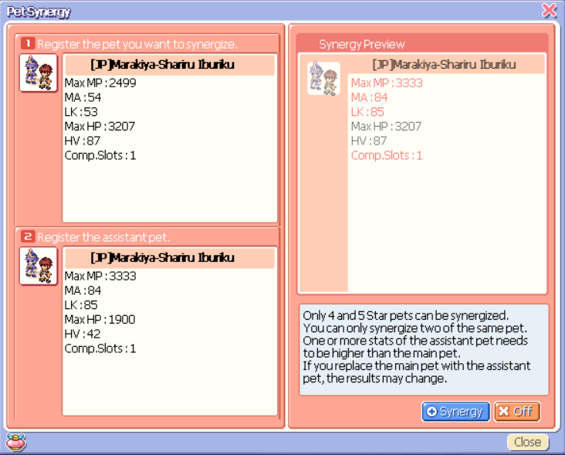
* Red in the “preview”: increased stats from the base (slot 1 pet) to the secondary (slot 2 pet) pet
* The order DOES NOT MATTER

### Driller Pets/AFK Pets

* Some pets allow you to do things AFK! Currently, all we have access to is driller pets, which come in various forms and stats and recharge times. If you want one with higher stats (I don’t particularly recommend this), feel free to buy a Driller Baby or the like, however, the *recharge coupon* cost skyrocket when you do.

**>Recharge Coupons:** MS-exclusive item used to “recharge” timed items to extend their time limit or turn on the timer once again. Can also be obtained with the Eternal Misc Box.

* You can get a Driller Boy for 3 days for 5.7k MS, or you can use Ari’s Exchange to get a grindable Driller Girl for 14 days for free with a lower recharge coupon rate.

# 

## Recycling - WIP

Coming soon

### Basic Info

* Recycling is a system used to reuse unwanted MyShop items
* To recycle, speak to **RecycleK MK 1** in certain shops (i.e. Paradise Shop, Mega Shop) and click “Recycling Paid Items”
* You obtain something called *Recycle Tickets*, which can be used to exchange for character boxes or scrolls in the Recycling Shop (accessed by speaking to the same NPC)
* Character box items are worth the most in terms of recycling, with 190-210 items being for 30 tickets each
* Regular MyShop box items range from 3-7 tickets usually, making them not worth as much to recycle unless you buy en bulk

## 

## Treasure Maps & Black Market - WIP

Coming soon

## 

## 1:1 Trading System

* In this game, there’s a way to privately give another player an item from your inventory, and that system is 1:1 trade
* To 1:1 trade a player, you Right Click > 1:1 Trade (see pic below)

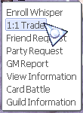

* You must then wait for the other player to accept the trade
* When they accept the trade, this screen pops up:

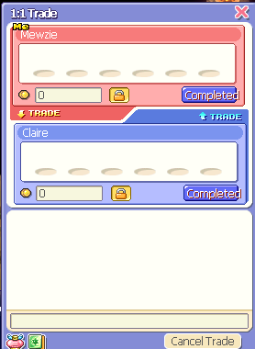*< Default Trade window*

* You can trade anything in your inventory/card inventory that does NOT say “untradable” on it when you right click it, as well as galder

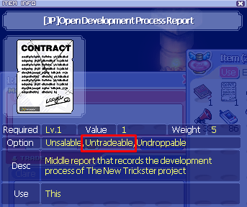 *< An example of an untradable item*

* You can trade galder by pressing the “lock” button, clicking on the 0, then typing a number. You finalize the number by clicking the Lock again. If you mess up, don’t worry, just repeat this mini-process!
* To trade an item, you must click and drag it into one of the slots on the trade screen. If you have multiple of the item, it will act as if you’re dropping it and ask the quantity (but it will not drop it–just add it to the trade menu)
* When you are completed, press the “Completed” button. Both parties must click this button in order to complete the transaction. When both parties have, the party that completed first must press the “Execute” button at the bottom, which appears next to the “Cancel trade” button when both parties have completed.
* Another window will pop up showing a summary of the trade, with two buttons–one “...” and one “Cancel”. The “...” turns into “Check” after a few seconds to give you time to review the trade. If either party does not press “Check” a few seconds after it appears (maybe 5-10?), it will cancel the trade entirely.

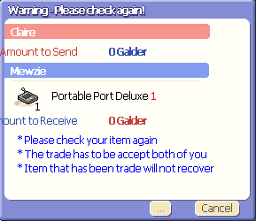 < *the check window*

* **WARNING**: If a party’s WT can’t support the items you are trading, it will show you! It will say “Weight Exceeded by” along with the amount of WT. The location of where it will show it depends on the party that is overweight. If it is you who is overweight, it will show up underneath the lock button on the dark red tab on the red half of the window. If it is your partner who is overweight, then it will show on the dark blue tab on the blue half of the window.

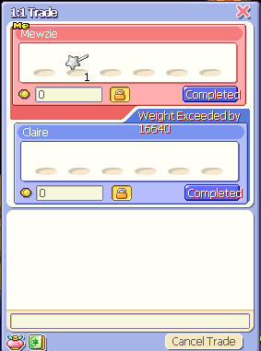 < *“Partner” being overweight*

* **WARNING**: If your trade partner does not have enough slots to support the items you give them, the trade will cancel when both parties press “check” and the items will be returned to their respective owners’ inventories as well as galder.

## 

## Parties & XP Share - WIP

Coming soon

## 

## Guilds

### General Info

* Guilds are groups of players who band together to achieve common goals!
* Some guilds are PvP oriented, some are PvE oriented, some focus on specific bosses, others focus on random bosses, etc. etc.
* Guilds currently provide no official in-game benefits other than a chatbox with other guild members and a shared Green name under your character’s name, along with an optional personalized guild title
* Guild points are useless and the in-game menu is broken currently

### How to join a guild

1. Login to the website
2. Press the Gray Guild button
3. [Optional] Select the character you want to join the guild on in the dropdown
4. Press Join next to your favorite guild
5. Wait for a reply!

## 

## Marriage - WIP

Coming soon

## 

## Quests + Questlog

### Basic info

- Quests are an easy way to level in this game

- You probably have completed at least one quest by the time you opened this (the tutorial)

- Quests mostly grant XP or TM, however some do not and only reward you with a third option

- You can accept a quest by talking to the associated NPC, assuming you have completed any necessary prerequisites

- There are 6 types of quests: Normal (not divided but there are several types), Monster (Mon), Party, Episode (Story), 3rd Job, and Key

- You can see details of any quest you have accepted in the Quest Log

- Unlike other servers, there is no (known) limit to the amount of Normal, Story, or Key quests you can accept!

### Quest Log

- Press **Q**

- This screen should come up

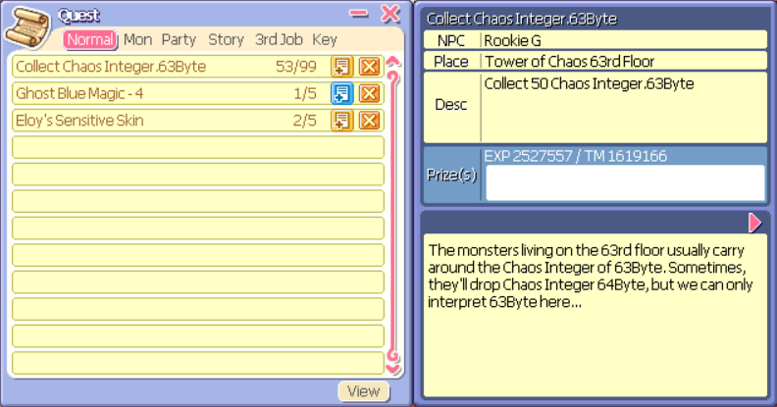

- You can see the number of cycles and the cycle you are at with the number next to the Quest View (+) and Cancel (X) buttons

- Some quests say X/99, these are generally unlimited quests that can be done indefinitely (report them if you can't!)

- Click on the name (yellow part NOT THE X) to view the information on the specific quest

- You can see the NPC, where the NPC is located, a description of what you need to do, the reward for THAT CYCLE ONLY (including XP and TM), and a brief of the chatlog you had with the NPC on the right

- You can see more of the chat log (if it's there) using the pink arrow on the right

- You can view COMPLETED quests (General Quest Record) by pressing View at the bottom of the Quest Window for that specific type of quest (change tabs to see the different ones), which shows the number of cycles completed and all the quests you have completed. Use this along with the wiki to troubleshoot if you are stuck on a questline!

- You can add or remove quests from your Quest View window by clicking on the + icon that is Blue when it is on your Quest View, and Yellow when it is not

- You can get rid of a quest by clicking the yellow Cancel button (X), but you will have to talk to the associated NPC again at the same location to retrieve said quest again (you will be on the same cycle you left off at, don't worry!)

## Fortune - WIP

Coming soon

Basic Info

* Fortune is a game mechanic that will buff specific stats
* These stats in most packs are most of your build stats (i.e. HV, MA, etc)
* Certain packs (i.e. #5, Year of the Hare) contain cards that buff EXP gain, Drop Rate, and Refine Rate

## 

## Compounding - WIP

Coming soon

## 

## Mature Compounding - WIP

Coming soon

## 

## Exchange - WIP

Coming soon

## 

## Guardian TLDR

### General Info

* Guardians are a familiar that follow you around. When you summon them, attack monsters but don’t have HP so you still tank the damage.
* Guardians learn skills based on their build graph, so if you have a 6 in power, it can learn 6 power-type skills
* The skills can be for first or second job only, but in order to learn second job skills, you need a rune. Only one 2nd job rune can be applied at a time.
* Their graph is built by you and your actions! If you plant (use) the seed, almost everything you do in game affects it, minus 1:1 Trade, picking up items (**NOTE: NOT GALDER! GALDER AFFECTS THE SEED!**), friend/party (be careful if you gain XP!)/guild request/applications, and banking items. Almost just about everything else you can think of affects the seed.
* There are guides out there that tell you how to build a guardian, but not necessarily skills. My guardian guide covers a build that works for every class that can solo Koiosu, one of the end game bosses in an area called Tartarus, with or without your input/skills/attacks. Yes, this is real.
* **If you need help on your guardian, check out my guardian guide here**: <https://docs.google.com/document/d/1aBNHRh0bInYsKX6B9D638mKOj80Wg3GiAmWLeu5m-50/edit#heading=h.lw1zytx4jlzs> It’s incredibly extensive and will be able to guide you through the whole process of obtaining and building your guardian.

### TLDR of How to Obtain One

* You get a guardian based on a questline as well as doing a new skill (Card ID) until you collect 16 different items called Secret Cards, which go for 1 mil for everything except SC 1 and 16, which both go for 15mil each. This means a guardian’s worth of SCs is 44mil on this server at minimum.
* The questline can be started at lv 65, but **I don’t suggest starting until you’re ready for the extensive graph building process+have at least 800-1k cards on you (*no, I am not kidding*).**
* The questline requires the Sandmen Quests in Mirage Field 4 to be completed in order to fully continue, this means you must complete at least Episode 3 Chapter 1 to obtain your guardian.

### How CID works

* In order to use Card ID, you must complete the first part of the 4 part questline to obtain the skill. It utilizes cards in your inventory,
* Each card affects CID based on their life, which you can see when you right click the card. Each life is how many chances at finding a pair you have before the game quits. This life count does not apply after the first stage, so it’s best to use +3 life cards from the second stage onward
* The best place to farm cards is Bad Fury in Cora Field 2.

### I Finished My Guardian, What Should I Do Now?

* Teach it skills! In my guide, I lead you through the koi hunter build as well as the required skills for it, and include builds for almost every single guardian type that would make your guardian viable, either by learning half or all of the skills required.
* Go to **Eclipse** in Skill Garden in Megalopolis with a *Popeye Anenome card* to obtain Mind’s Eye and be able to unlock new areas and a new party gamemode–Harkon Defense–to farm crests to mature compound with your gear.
* Depending on your build, use it! Some builds are good for DPS such as the koi hunter build while others are good for farming such as a high Magic type.

## 

## Harkon Defense TLDR - WIP

Coming Soon

### General Info

* Harkon Defense is a tower defense party gamemode where you team up with other players in order to defend Harkon Statues from waves of monsters, and eventually, a final boss (a weakened Kronos).
* This is a good way to collect Shards, which are used to exchange for Crests once you finish Episode 5+6 (requires a guardian to complete). Crests are used for near maximum rolls for equipment lv 200-250, but can be used up to ~290 to substitute for average or high average rolls.
* You can also exchange Shards for Magic Stones in Event Garden.

## 

## Bossing TLDR - WIP

Coming soon

* You need about 600+ LK and 250+ HV to counter just about any boss, including Kronos
* You can use brooms from Ari’s Exchange to skip trials
* There is no level caps for bosses anymore, just minimums, so you can be level 91 and kill Tut, but not level 1 and kill Karan (without brooms)
* Average number of seals required for a drop (Pre-Tartarus): 50-200
* Average number of seals required for a drop (Koiosu): about 250~333 based on staff testing
* Average number of seals required for a drop (Kronos): not enough data to estimate

## 

## Post-end Game PvE Tips to Keep Playing!

### About This Section

* I have a strong belief that there is almost always something to do or grind in Trickster, you just either lack the knowledge or the desire to continue your gaming experience
* This section is for those that struggle with the former, not the latter. If you are the latter, that is an internal issue that you should look within yourself for answers for.
* Trickster only limits you as much as you limit yourself in terms of end game content. There is plenty to do, it is just not nearly as instantly gratifying as the early to mid game.
* Try to keep an open mind about Trickster. It is a very old game but your limit is genuinely your imagination and will to grind, but there is plenty to do (and flex, if you're into that) when all is said and done.

### Have you…..

* Hit level 400 yet?
* Collected all the CT titles?
* Collected all the boss seals?
* Collected at least one piece of equipment from each pre-tartarus boss?
* Tried your hand at tartarus yet?
* Collected all the boss uniques pre-tartarus and their associated accessory quests?
* Started a lucrative business venture filling a niche in the market on the server?
* Got Crest rolls or higher on all your equipment?
* +13'd your battle gear?
* +13'd your boss uniques?
* Completed all the quests, or at least key quests and Episode quests (doesn't have to be all normal quests; don’t overwhelm yourself)?
* Collected one of each guardian available to you (1 regular guardian and 5 spinel types [Regular, Superior, Mighty, Legendary, Accomplished])?
* Made a character with an unconventional build and tried to make it viable (i.e. CyberHunter lucky fist/LK build)?
* Found an iconic outfit to use for your fuses on your main battle gears?
* Sorted, organized, and cataloged all your items in your storage/inventory on your storage characters, if you have any?
* Written a guide on something you know about that could benefit the community/archival of the game?
* Created a successful guild or conglomerate of friends?
* Helped a bunch of random newbies out in some way over the course of your stay?
* Made friends and had a good time?
* Took lots of screenshots?
* Collected a bunch of fuses?
* Hoarded (or gave/sold) a dragon's lair of wealth?
* Hosted your own player-sponsored server event or made a recolor/fuse for the server?

### Uphill Grinds Of Godly Flexhood

**NOTE**: These are vanilla grinds, meaning they can be done at any time!

* 2.4bil galder (max amount you can have; won’t let you trade for more)
* All the CT Titles+Adjucator (all available titles [61])
* Accomplished guardian(s) (Hardest guardian type; requires precise planning)
* 4s Requiem Flame Helm (BIS AP helm + temperable DP/AC)
* Karan Pearl Pistol (and skin it!)
* 4s Powerful Regal Shield (with 1788 dp temper or higher)
* Goddess equipment (charm+mage type end game EQs)
* Koiosu Ring/equipment (other than staff/gun)
* Kronos Ring/equipment (requires Paula or a Paula to farm Key 9 for you, or insane stats)
* 4s Altiverse Maiden Staff (81+MA/43+LK; BIS elec mages) or Mace (1.3k+ AP; end game gear for buffalo/hybrid bunny)
* 4s Altiverse Maiden/Crimson in general (marker to go for: 75% of max range of important stats or more, depending on your patience and budget)
* Ultimate Amadas Set (end game gear for wind mages/DL)
* “Meme” gear drops (Phantom Arc Stick [can go completely negative in stats]; Lucky 7 [7 Gun AP and 7 7 7 item comps]; etc.)

### When All Else Fails…

* MAKE A NEW CHARACTER!!!
* Figure out things you can grind to in terms of level and the quickest path of least resistance to your goal
* Try researching different ingame events not yet implemented but are vanilla (i.e. the karu event) and figure out a swift path to grinding characters to the minimum level for that event so you can farm it later
* Try seeing if you can figure out a better quest leveling system than FastLane for event/episode/mail reward spam!
* Try different builds, try different equipments, try different skills, try different classes
* Make a whole zoo of colorful, varied characters!
* Make a Driller army to hoard wealth and resources
* Make a wind sheep army to farm cards, Eternal tickets, and galder, depending on how powerful you make them
* Make a Paula to farm Kronos/special event bosses (i.e. GM Stella’s Janus)
* DO IT ALL OVER AGAIN!!!!!!!!! Yes, ***EVERYTHING***!!!! EVERYTHING YOU CAN STOMACH!!!!! >:3c

## PvP Tips - WIP

### DISCLAIMER:

I am incredibly new to PvP–I am just writing down all of my notes here for public information, in hopes more people join PvP and improve their skills, as I do, as well.

### Quick List of Counters:

**“Bubble”/Magical Soul** (mages) -> Rust (Mages only)

**Lightning Strike/”LS”** (buff+duelist) -> RNG

**Electro Attack/Electroshock** (elec sheep+wiz) -> Clinch release (bunny+merc only); Elec % Resist; Medcure (priest only)

**Shard of Glacier** (water [usually primarily elec] sheep+wiz) -> Clinch release (bunny+merc only)

**“Bomb”/Mass Destruction** (raccoons+divas) -> Electro Attack (elec sheep+wiz only); Mental Breakdown/”Paula Slow”; Dark Distractor/”Dark Lord Slow”; RUN!!!!!!!!!!!!!!!!!!!!!!!!!!!!!!!!!! For the ballsy: knock down some of his health by casting something quick in the first two seconds of bomb and you should be able to get out of there, and if not, you will have negated hopefully enough damage to live (good luck)

**Mental Breakdown/”Paula Slow”** (Paula) -> HAHAHAHAHAHAHA GOOD ONE

**Dark Distractor/”Dark Lord Slow”** (Dark Lord) -> MedCure or Basic Healing? (Priest, or light witch+dragon only)

**Rust** (mages) -> MedCure (Priest only); Basic Healing (Light witch+dragon only)

**Mana Web** (mages) -> MedCure (Priest only); Basic Healing (Light witch+dragon only)

**Icey Shackles** (water [usually primarily elec] sheep+wiz) -> ????

**Hinder Snare** (dark dragons+witches) -> hahahahahhahaha

**Flaming Fist** (champs)-> Fire % Resist

**Catastrophic Fen** (soulmaster) -> Dash (bunny+merc only)

**Shockvibe** (powers) -> MedCure (Priest only); Basic Healing (Light witch+dragon only)

**Sense Breaker** (powers) -> MedCure (Priest only); Basic Healing (Light witch+dragon only)

**Luck Breaker** (powers) -> MedCure (Priest only); Basic Healing (Light witch+dragon only)

**Armor Breaker** (powers) -> MedCure (Priest only); Basic Healing (Light witch+dragon only)

**Sticky Foot** (sense) -> MedCure (Priest only); Basic Healing (Light witch+dragon only)

**Armor Destructor** (sense) -> MedCure (Priest only); Basic Healing (Light witch+dragon only)

**Magic Meltdown** (charms) -> MedCure (Priest only); Basic Healing (Light witch+dragon only)

**Magic Def Breaker** (charms) -> MedCure (Priest only); Basic Healing (Light witch+dragon only)

**Skunk Pouch** (charms) -> MedCure (Priest only); Basic Healing (Light witch+dragon only)

**Fear** (dark lord) -> MedCure (priest only)

**Wicked Flame** (dark lord) -> MedCure (priest only)

**Deadly Funk** (cats+dukes) -> MedCure (priest only)

**Sticky Icky** (foxes+cyberhunter) -> MedCure (priest only)

**Entrancing Wink** (primadonna) -> MedCure (priest only)

**Guard** (bunny+merc) -> Arrow Rush (mages; goes thru guard); any skill that does multiple hits, even if they are negligible damage; Bubble (mages) goes thru guard

### Notes on Combat

#### To hit

Charms -> AC

Sense (Scientist)-> AC + LK

Mages -> LK

#### In General

AC = Auto Attack (to hit)

LK = Skill (to hit)

HV = Auto Attack (to dodge)

LK = Skill (to dodge)

For every 100 HV, you need about 250-300AC to hit

#### Damage Calculations

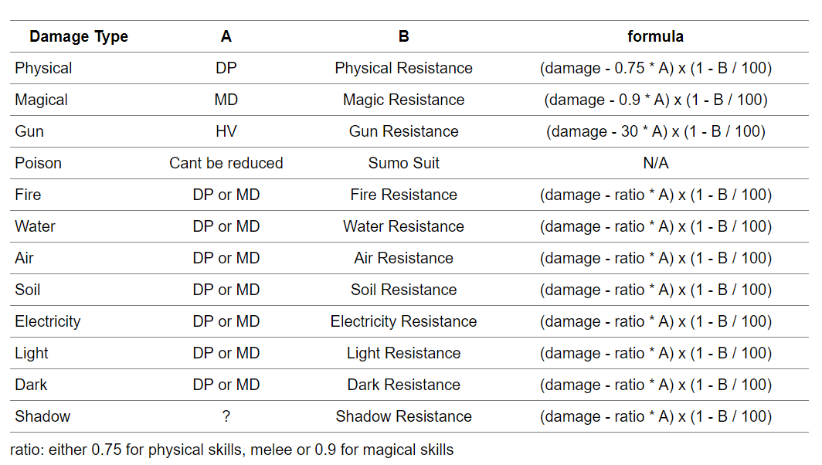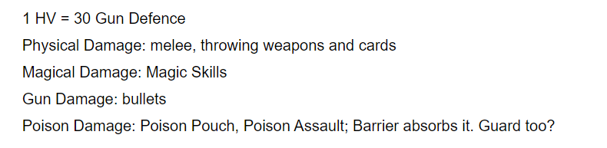

#### How Each Character Seems to Play

Disclaimer: This is based on observation and (limited) personal experience.

##### Powers:

* Champion: One hit powerhouse; FF build preferred; guard away
* Duelist/Mercenary: LS+guard spammer; sometimes varied by element (usually air or water, but never soil or fire that I’ve seen)
* Gladiator: I’ve only seen one mf crazy enough to do this but bunny guard is really good and this mf was water
* Paula: Slow -> Rain of Hammers -> Win. Can be done with PvE gear and maybe one or two PvP gears.

##### Mages:

* Witch -> Always go light. Swiss army knife from Wish. Electro+shard (aka Water/Elec), crowd control (i.e. stuns, debuffs) primarily with slight tank. Bubble build (aka DPS) is possible but probably not preferred, although it’s super fun. Build with LK and MA in mind. Quick casting and constant movement is necessary. Use 3 primary sets for your witch: LK (cc), MA, bubble.
* Soulmaster -> VERY FUN!!!! But very hard!!!! Needs a LOT of balancing with equipment that can end up leaving you in a weaker state compared to a Witch, especially without Shield of Heaven, however, Catastrophic Fen is absolutely amazing and watching people run in place was very rewarding. Constant, constant movement, concentration, and awareness is required. Requires insane gear to compete. You need FOUR sets for this character: Bubble, LK, MA, and HP.
* Dark Lord -> Slow casts but deep cuts; cc.
* Priest -> Buff and cleanse machine; swiss army knife from carolus rex himself. Bubble works amazing with this build, especially due to medcure. Medcure is insane.

##### Sense:

* Scientist -> Glass cannon and terror to mages; incredibly quick casting; requires insane amount of AC+LK to be good
* Cyberhunter -> ???????????????????? Doesn’t exist. Probably a debuff mf.
* Hunter Lord -> ?????????????????????????????????????????????????? Help
* Thief Master -> Hide + Exploit Weakness. With enough sets and a smart head behind the wheel, this character can kill anyone and everything. However, she is INCREDIBLY hard for beginners and I would not recommend her unless you are 1. Ready to invest in 4 sets of gear (AC, HV, LK, DA) 2. Experienced in quickswapping+balancing gear 3. Ready to EXPERIMENT! 4. EXPERIENCED!!!!!!!!!!!!!!!!!!!

Charms: